Supplementary Material – Online Appendices
Online Appendix A: Details about the sample
In this online Appendix, we present the explanations for the sample selected for each exercise (Table 1A).
Table 1A Conducted exercises

Exercise | Countries included
Exercise 1: disposable income inequality | 15 countries: Australia, Belgium, Canada, Denmark, France, Finland, Germany, Ireland, Italy, Japan, the Netherlands, Portugal, Sweden, the United Kingdom, and the United Sta-  tes.
Exercise 2: market in- come inequality | 13 countries: Australia, Belgium, Canada, Denmark, France,  Finland, Germany, Italy, Japan, the Netherlands, Portugal, the United Kingdom, and the United States.
Exercise 3: gross wage inequality | 14 countries: Australia, Austria, Belgium, Canada, Denmark, France, Finland, Germany, Ireland, Netherlands, Spain, Swe-  den, the United Kingdom, and the United States.
Exercise 4: gross ear- nings inequality (per-  centile ratio 50/10) | 14 countries: Australia, Austria, Belgium, Canada, Denmark, France, Finland, Germany, Ireland, Japan, Portugal, Sweden,  the United Kingdom, and the United States.
Exercise 5: gross ear- nings inequality (per- centile ratio 90/50) | 15 countries: Australia, Austria, Belgium, Canada, Denmark, France, Finland, Germany, Ireland, Japan, the Netherlands, Portugal, Sweden, the United Kingdom, and the United Sta-  tes.
Exercise 6: gross ear- nings inequality (per-  centile ratio 90/10) | 13 countries: Australia, Austria, Belgium, Canada, Denmark, France, Finland, Germany, Ireland, Japan, Sweden, the Uni-  ted Kingdom, and the United States.
Exercise 7: labor share in GDP | 15 countries: Australia, Belgium, Canada, Denmark, France, Finland, Germany, Ireland, Italy, Japan, the Netherlands, Portugal, Sweden, the United Kingdom, and the United Sta-  tes.
- Source: author’s elaboration.

In Exercise 1 of the baseline model, we incorporated data from 15 countries: Australia, Belgium, Canada, Denmark, France, Finland, Germany, Ireland, Italy, Japan, the Netherlands, Portugal, Sweden, the United Kingdom, and the United States. Austria and Spain were omitted from this baseline due to concerns about stationarity related to the dependent variable. However, we reintroduced these countries in the online Appendix B (refer to Figure 4B), and our analysis confirms the robustness of the results with their inclusion.
Exercise 2 encompasses data from 13 countries: Australia, Belgium, Canada, Denmark, France, Finland, Germany, Italy, Japan, the Netherlands, Portugal, the United Kingdom, and the United States. Again, we opted to exclude Austria and Spain from the baseline due to concerns regarding stationarity issues related to the dependent variable. The robustness of the results is further validated in Appendix B, where we include these two countries - see Figure 8B. Also, Ireland and Sweden were excluded from the baseline sample because the inclusion of these countries produced results that were not robust across alternative specifications. Specifically, certain fiscal episodes in these countries drove changes in the medium-run estimates, leading to non-significant effects when compared to other robustness checks. This approach follows Cardoso and Carvalho (2023), who adopt similar procedures to ensure that baseline estimates reflect stable and consistent patterns rather than being driven by outlier episodes.
Exercise 3 includes 14 countries: Australia, Austria, Belgium, Canada, Denmark, France, Finland, Germany, Ireland, Netherlands, Spain, Sweden, the United Kingdom, and the United States. We excluded Japan, Italy, and Portugal due to data availability.
The baseline for Exercise 4 includes 14 countries: Australia, Austria, Belgium, Canada, Denmark, France, Finland, Germany, Ireland, Japan, Portugal, Sweden, the United Kingdom, and the United States. Spain had limited observations, totaling just four, leading to its exclusion from the baseline. However, to maintain a comprehensive analysis, we employed linear interpolation to incorporate Spain's data (as in Heimberger, 2020) to include this country in the sample, as depicted in Figure 16B of the online Appendix B. Our decision to exclude Italy from the baseline in Exercise 4 was influenced by its substantial impact on the panel data results, aligning with the approach of Cardoso and Carvalho (2023). The inclusion of Italy appeared to significantly alter the outcomes, presumably due to specific shocks affecting the results related to earnings inequality, encompassed in Exercises 4-6. For the sake of robustness and consistent results, Italy was deliberately omitted from the sample for these equations. Moreover, the Netherlands was also excluded from the sample for Exercise 4, as including it without Italy compromised the robustness of the results. When including both Italy and the Netherlands, the effect of austerity shocks on the 50/10 percentile ratio in the medium run becomes positive and statistically significant. However, this positive impact in the medium run is not robust when we exclude these countries. In the online Appendix B, we reintroduced Italy and the Netherlands (refer to Figure 16B), reaffirming the highly robust positive impact of austerity shocks in the short run while incorporating these countries.
The baseline analysis for Exercise 5 involved estimation using data from 15 countries: Australia, Austria, Belgium, Canada, Denmark, France, Finland, Germany, Ireland, Japan, the Netherlands, Portugal, Sweden, the United Kingdom, and the United States. Italy's exclusion from this exercise was motivated by its notable influence on altering results in the medium run, consistent with prior observations. When including Italy, results revealed a negative impact of austerity measures on the 90/50 percentile ratio in the medium run. However, this effect lacked statistical significance and was not robust when Italy was excluded from the sample. In the short term, however, the impact remained robust with Italy's inclusion -see Figure 21B of the online Appendix B. Furthermore, Spain had limited observations in the baseline data, prompting its exclusion from the initial analysis. Nonetheless, we reintroduced Spain in the online Appendix B (Figure 21B) to maintain a comprehensive approach, utilizing linear interpolation to account for data scarcity. The subsequent results affirm the robustness of the findings.
The baseline estimation for Exercise 6 involved data from 13 countries: Australia, Austria, Belgium, Canada, Denmark, France, Finland, Germany, Ireland, Japan, Sweden, the United Kingdom, and the United States. Italy was intentionally excluded due to the previously noted concerns regarding its impact on measures of earnings inequality. However, it is noteworthy that the robustness of this exercise was confirmed even with Italy's inclusion, as demonstrated in the online Appendix B (refer to Figure 26B). Additionally, Spain, the Netherlands, and Portugal were excluded from the baseline due to the limited observations available in the dataset. To ensure comprehensive analysis, we reintroduced these countries in the online Appendix B (Figure 26B) using linear interpolation to address data scarcity. The subsequent results confirm our results are robust.
Lastly, Exercise 7 was estimated using data from 15 countries: Australia, Belgium, Canada, Denmark, France, Finland, Germany, Ireland, Italy, Japan, the Netherlands, Portugal, Sweden, the United Kingdom, and the United States. Austria and Spain were deliberately excluded from the baseline due to concerns related to the stationarity of the dependent variable. However, to provide a comprehensive analysis, we incorporated these two countries in the online Appendix B (refer to Figure 31B). Notably, the results remained highly robust when including Austria and Spain.

Online Appendix B: Robustness checks
In order to further test the robustness of the baseline results, we conducted several additional tests. Firstly, we explored the impact of using an alternative number of lags to assess its effect on the estimated coefficients. Secondly, we examined the influence of different control variables on the outcomes. Finally, we tested the robustness of our findings by using alternative samples of countries, ensuring that the results hold across different contexts.
These robustness checks provide additional confidence in the reliability of our conclusions. We present the results considering the years in which the responses are more strong or statistically significant, in the short and medium run. For example, for disposable income inequality, the peak response for total and spending-based shocks occurs in the ninth year, while for tax-based ones, it happens in the fourth year. For market income inequality, the peak response for total and spending measures occurs in years three and eight for the short and medium run, respectively. For tax-based episodes, it occurs in years three and six. The coefficients are presented along with one standard deviation band around them.
Figures 1B-4B present the alternative estimations for Exercise 1. To investigate the sensitivity of our results to the number of lags, we conducted tests by varying the number of lags of fiscal shocks (Figure 1B). The baseline model includes two lags and is referred to as "2" in the graph. Additionally, we examined the impact of changing the number of lags of the dependent variable (Gini index) in the analysis (Figure 2B). The baseline model includes one lag. As we can see, results are robust to changes in the model specification.
Figure 3B presents the results with different sets of control variables. We considered the variables recommended by the literature (as described in Section 3.1): "a": all variables (all control variables are included); "g": real GDP growth rate; "i": inflation rate; "pc": real GDP per capita (baseline); "t": trade-to-GDP (openness); "u": unemployment rate, "w": without control variables. In addition, we conducted tests with the same control variables but adding one lag, denoted as "al", "gl", "il", "pcl", "tl", and "ul". Figure 4B displays the estimations when we exclude one country from the sample. The results remained consistent across various specifications, indicating that the impact of fiscal shocks on inequality is robust and not heavily influenced by the choice of control variables or the countries included in the sample.
Figures 5B-8B represent the same tests for Exercise 2. The outcomes demonstrate a consistent pattern of robust results across the majority of tests. However, Figure 7B stands out, revealing that the short-term (third year) impact of tax-based measures on market income inequality loses its robustness when controlling for additional variables, specifically GDP growth and per capita income level. The observed effect in Figure 7B is not statistically significant, indicating the need for cautious interpretation when accounting for these control variables. On the other hand, the effect of spending-based shocks is highly robust.
Figures 9B-12B display the test results for Exercise 3, focusing on wage inequality. Notably, the results consistently demonstrate robustness across various test scenarios, indicating the stability of findings in the face of alterations.
Moving to Figures 13B-17B, we present the standard tests for Exercise 4, showcasing the baseline results for earnings inequality with a focus on the percentile ratio 50/10. These results remain robust throughout the tests, reaffirming the stability and reliability of our baseline findings.
Furthermore, in Figure 17B, we present an additional test for the percentile ratio 50/10. Linear interpolation was applied to address missing data in the series (Heimberger, 2020), and the results indicate minimal changes, further underlining the stability and robustness of our findings even when accounting for data imputation.
Figures 18B-22B showcase our tests focusing on earnings inequality, specifically examining the percentile ratio of 90/50 (Exercise 5). Figures 21B and 22B provide crucial insights: they reveal that the previously identified negative impact of austerity on earnings inequality 90/50 is not robust. This lack of robustness is particularly pronounced in Figure 22B, where we employed linear interpolation to address missing data in the series. In this case, the negative impact transitions to a state of statistical non-significance. These findings suggest that the observed negative effect should be interpreted with care.
Figures 23B-27B present tests for earnings inequality using the 90/10 percentile ra-
tio (Exercise 6), while Figures 28B-31B depict similar tests for the labor share exercise (Exercise 7). As evident, the baseline results remain robust across all variations.
Figures 32B-38B demonstrate high result robustness when altering the narrative shocks database. In this analysis, we utilized the prevalent database in the literature: Devries et al. (2011), for 1978-2009, and Alesina et al. (2019), for 2010-2014. Figures 39B-45B confirm the robustness of the results using different databases: Devries et al. (2011), for 1978-2009; Alesina et al. (2015), for 2010-2013; and Gupta et al. (2017), for 2014.
Figures 46B-51B show the usual tests for the redistributive measure exercise, showing that the outcomes are resilient in the face of alterations.
We also estimated Exercises 1-7 separately for spending-based and tax-based shocks following Heimberger (2020) and Cardoso and Carvalho (2023). However, concerns have arisen regarding potential bias in the results since some episodes in the database involve both spending and tax-based measures. To address this concern, we conducted a robustness test, following the approach proposed by Heimberger (2020). In this test, we categorize measures as spending-based when the absolute magnitude of the shock exceeds that of the corresponding tax-based shock and vice versa.
The results are available in Figures 52B-61B. Remarkably, these results demonstrate a high degree of robustness to this adjustment. The most notable change observed pertains to: i) the impact of tax-based shocks on wage inequality (Figure 54B). It remains statistically significant at the 10% level in year 4. However, the effect in the medium run (years 7 and 8) becomes zero (considering the one standard deviation band, most used in the literature, as in Cardoso and Carvalho, 2023 - see Figure 60B); ii) the impact of tax-based shocks on the earnings inequality measured by the 90/50 measure becomes statistically significant at 10% and positive in the medium run (eighth year) (Figure 56B). However, this result is not robust when we used interpolated data; iii) the impact of tax-based shocks on the earnings inequality measured by the 90/10 measure becomes statistically significant at 5% and positive in the medium run (seventh and eighth year) (Figure 57B). This result remains statistically significant in the medium run when using interpolated data; iv) the redistributive effect lacks significance (Figure 59B). However, Figure 61B shows that, considering the most used interval in this literature (one standard deviation band - Cardoso and Carvalho, 2023), the effect is still significant in the short term after spending-based measures.
Fig.1B Impact of fiscal consolidation (of 1% of GDP) on disposable income inequality - Different lags of the fiscal shock
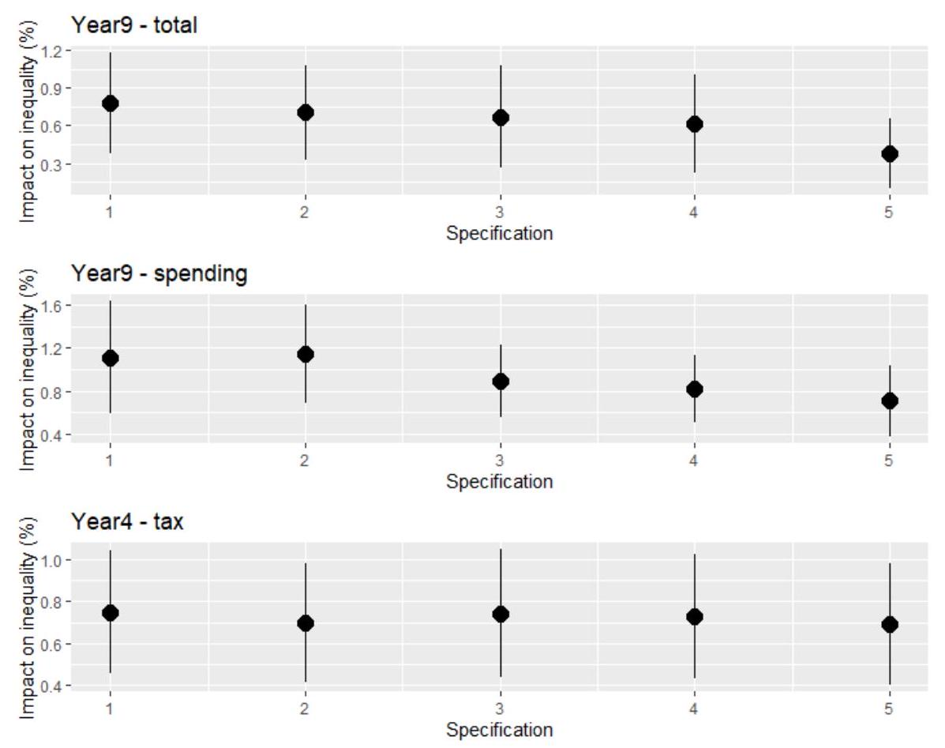
Source: Author's calculations. We present the coefficients with one standard deviation band around them. The baseline includes two lags and refers to “2” in the graph.

Fig.2B Impact of fiscal consolidation (of 1% of GDP) on the disposable income inequality – Different lags of the inequality measure
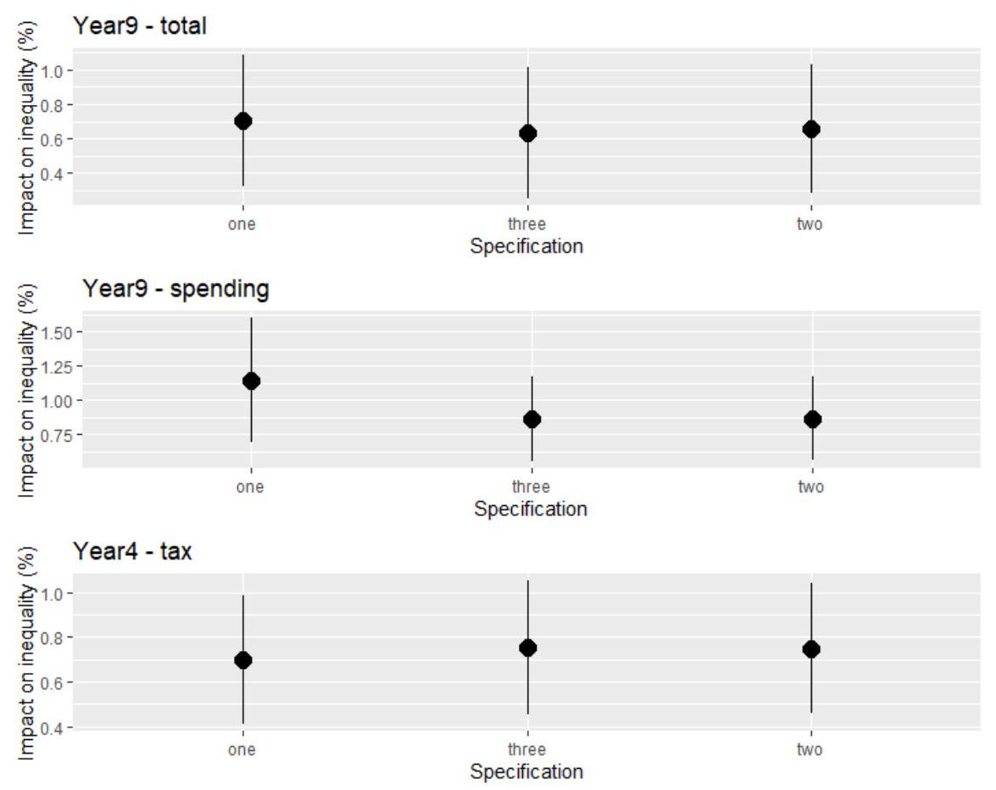
Source: Author's calculations. We present the coefficients with one standard deviation band around them. The baseline one lag and refers to “one” in the graph.
Fig.3B Impact of fiscal consolidation (of 1% of GDP) on the disposable income inequality - Different control variables
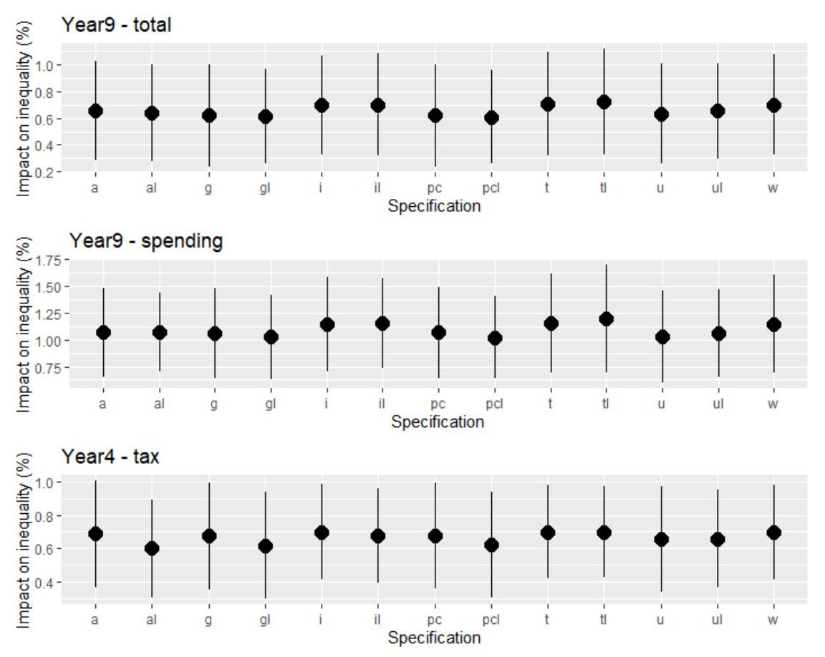
Source: Author's calculations. We present the coefficients with one standard deviation band around them. "a": all variables (all control variables are included), "g": real GDP growth rate, " i ": inflation rate, "pc": real GDP per capita, "t": trade-to-GDP (openness), "u": unemployment rate, "w": without control variables (baseline). "al", "gl", "il", "pcl", "tl" and "ul" control for the same variables, but adding one lag.
Fig.4B Impact of fiscal consolidation (of $1\%$ of GDP) on the disposable income inequality - Different countries
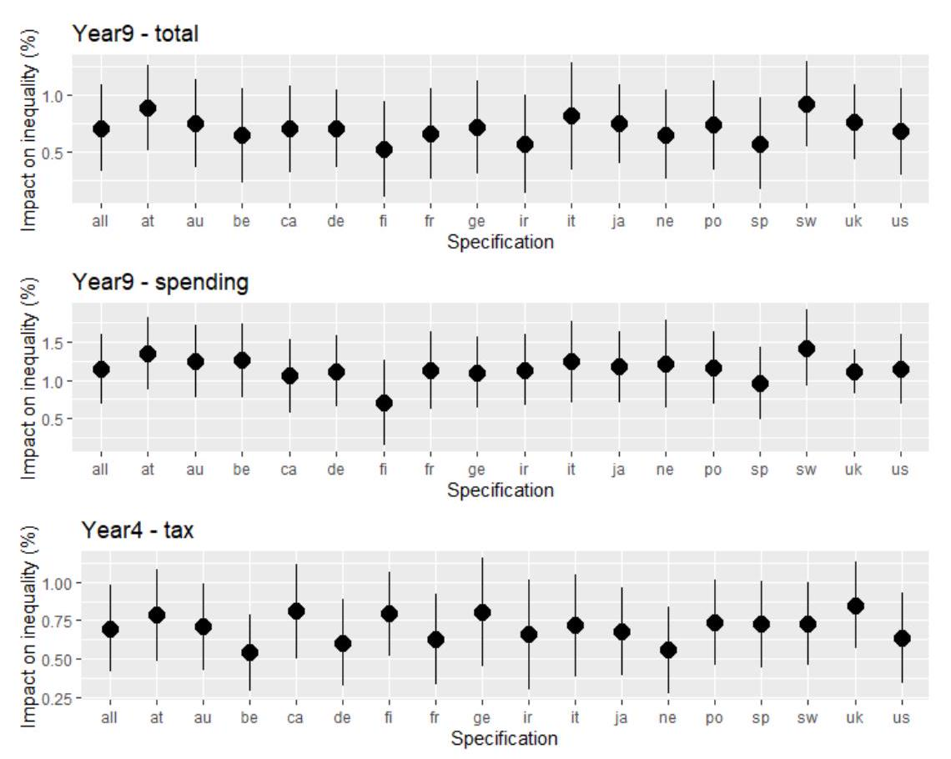
- Source: Author's calculations. We present the coefficients with one standard deviation band around them. "all" includes all countries (baseline), "at" includes Austria, "au" excludes Australia, "be": excludes Belgica, "ca": excludes Canada, "de": excludes Denmark, "fi" excludes Finland, "fr" excludes France, "ge" excludes Germany, "ir" excludes Ireland, "ne" excludes Netherlands, "sp" includes Spain, "sw" excludes Sweden, "uk" excludes the United Kingdom, "us" excludes the United States.

Fig.5B Impact of fiscal consolidation (of 1% of GDP) on the market income inequality - Different lags of the fiscal shock
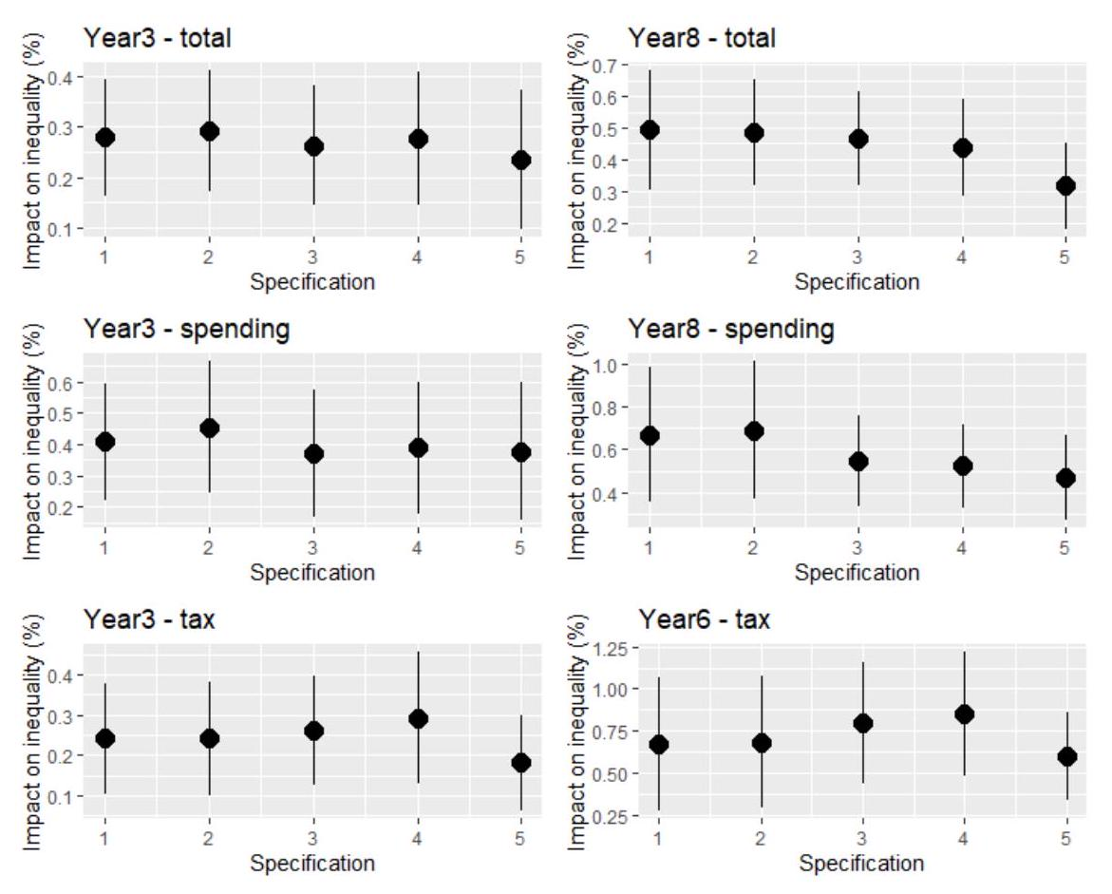

Source: Author's calculations. We present the coefficients with one standard deviation band around them. The baseline includes two lags and refers to “2” in the graph.
Fig.6B Impact of fiscal consolidation (of 1% of GDP) on the market income inequality – Different lags of the inequality measure
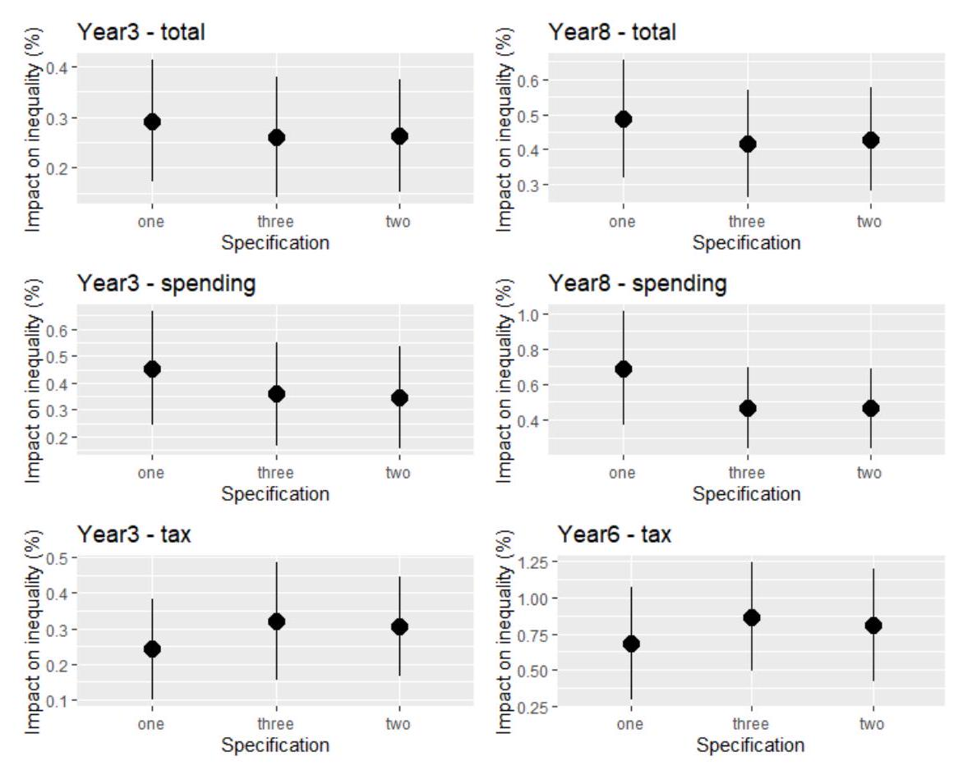
Source: Author's calculations. We present the coefficients with one standard deviation band around them. The baseline includes one lag and refers to “one” in the graph.
Fig.7B Impact of fiscal consolidation (of 1% of GDP) on the market income inequality - Different control variables
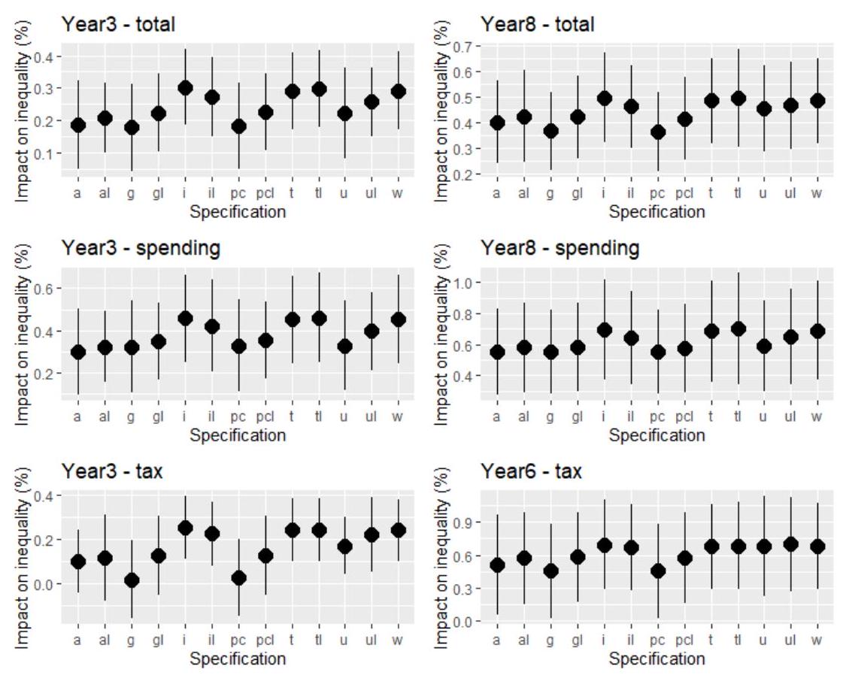
Source: Author's calculations. We present the coefficients with one standard deviation band around them. "a": all variables (all control variables are included), "g": real GDP growth rate, " i ": inflation rate, "pc": real GDP per capita, "t": trade-to-GDP (openness), " u ": unemployment rate, "w": without control variables (baseline). "al", "gl", "il", "pcl", "tl" and "ul" control for the same variables, but adding one lag.

Fig.8B Impact of fiscal consolidation (of 1% of GDP) on the market income inequality - Different countries
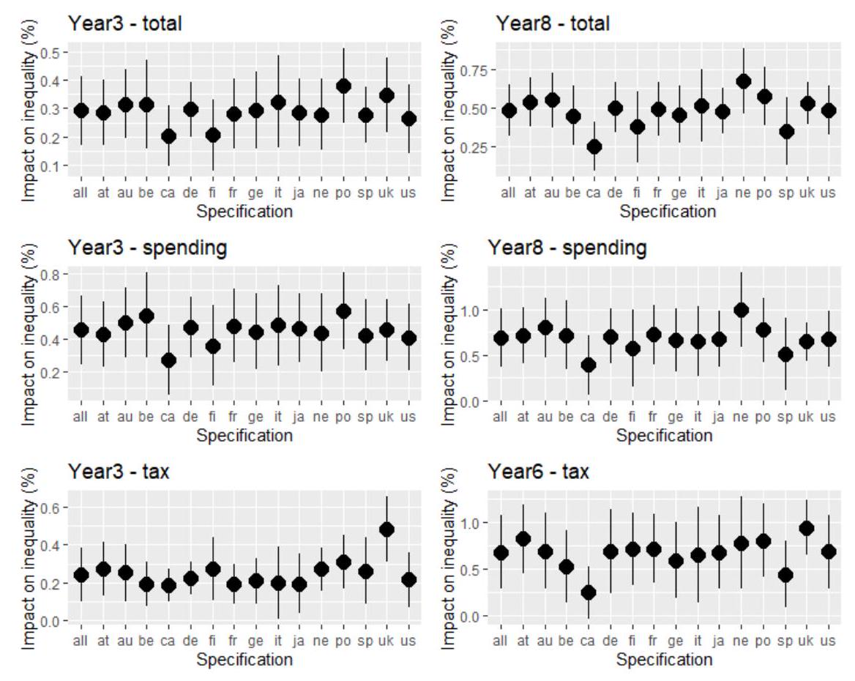
- Source: Author's calculations. We present the coefficients with one standard deviation band around them. "all" includes all countries (baseline), "at" includes Austria, "au" excludes Australia, "be": excludes Belgica, "ca": excludes Canada, "de": excludes Denmark, "fi" excludes Finland, "fr" excludes France, "ge" excludes Germany, "ne" excludes Netherlands, "sp" includes Spain, "uk" excludes the United Kingdom, "us" excludes the United States.

Fig.9B Impact of fiscal consolidation (of 1% of GDP) on gross wage inequality - Different lags of the fiscal shock
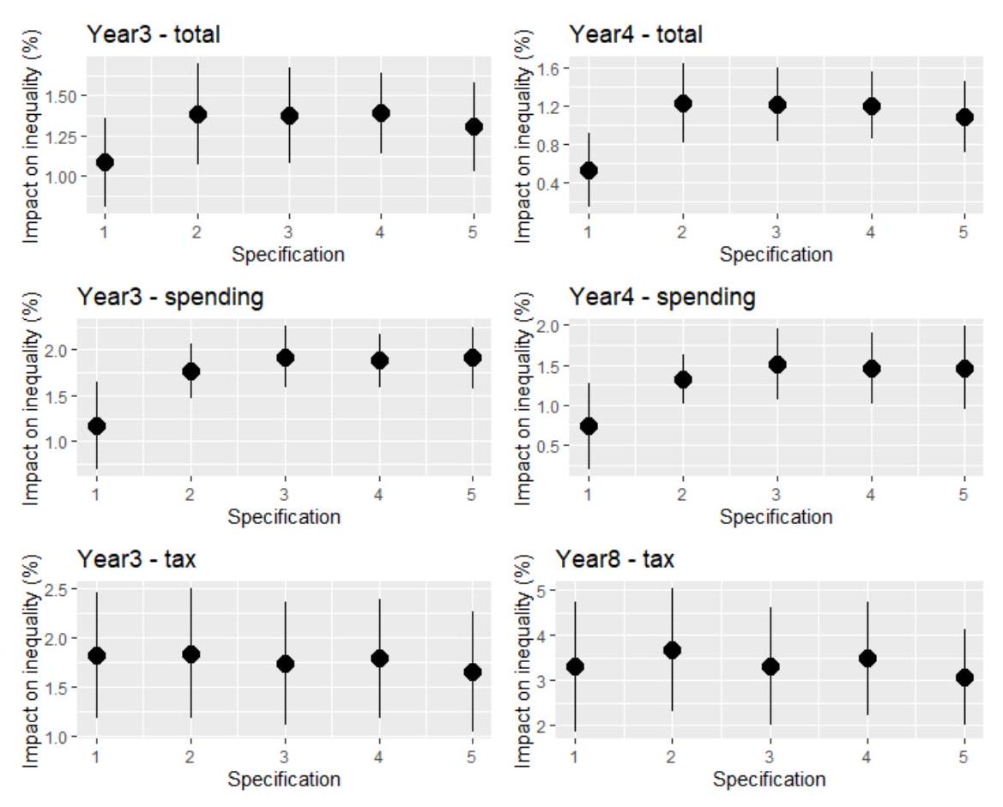
Source: Author's calculations. We present the coefficients with one standard deviation band around them. The baseline includes two lags and refers to “2” in the graph.
Fig.10B Impact of fiscal consolidation (of 1% of GDP) on gross wage inequality - Different lags of the inequality measure
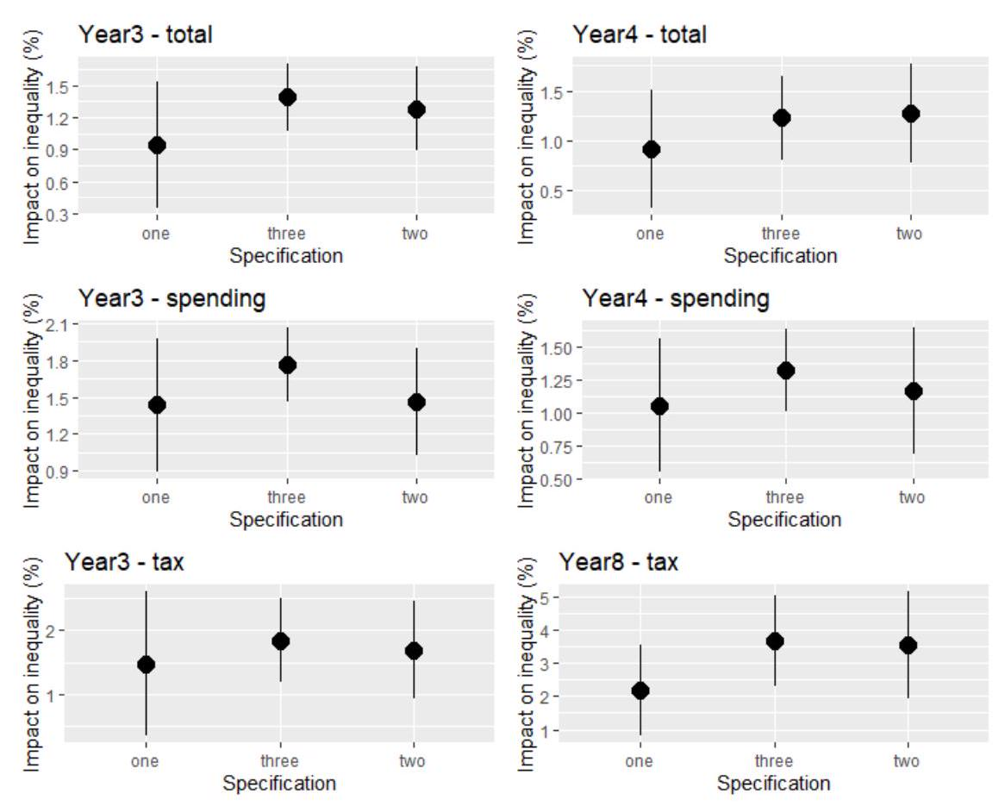
Source: Author's calculations. We present the coefficients with one standard deviation band around them. The baseline includes three lags and refers to “three” in the graph.
Fig.11B Impact of fiscal consolidation (of 1% of GDP) on gross wage inequality - Different control variables
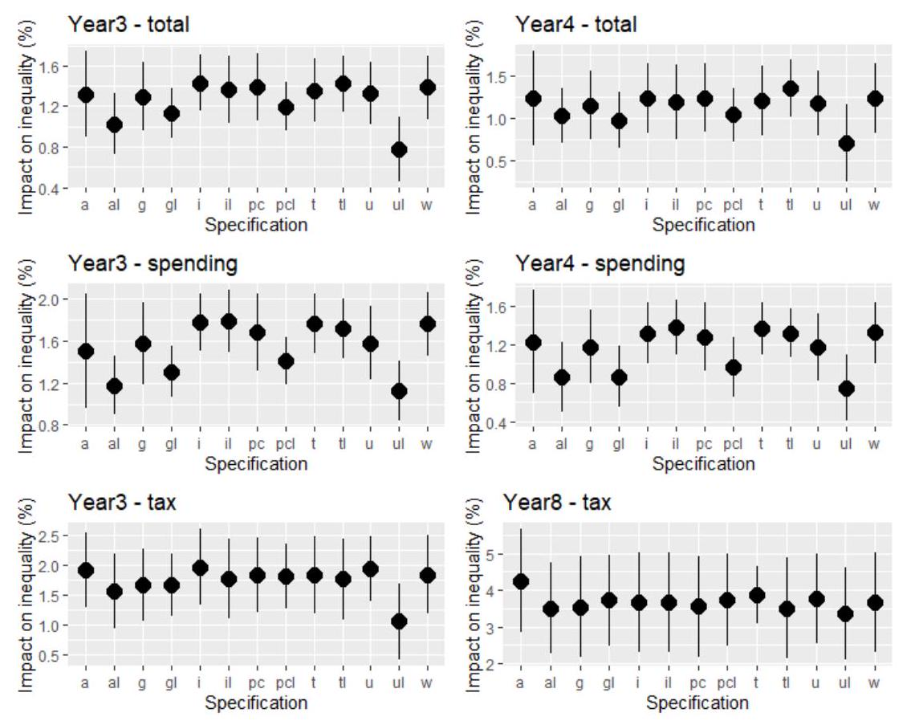
Source: Author's calculations. We present the coefficients with one standard deviation band around them. "a": all variables (all control variables are included), "g": real GDP growth rate, " i ": inflation rate, "pc": real GDP per capita, " t ": trade-to-GDP (openness), " u ": unemployment rate, "w": without control variables (baseline). "al", " gl ", " $il"$, "pcl", "tl" and "ul" control for the same variables, but adding one lag.

Fig.12B Impact of fiscal consolidation (of 1% of GDP) on gross wage inequality - Different countries
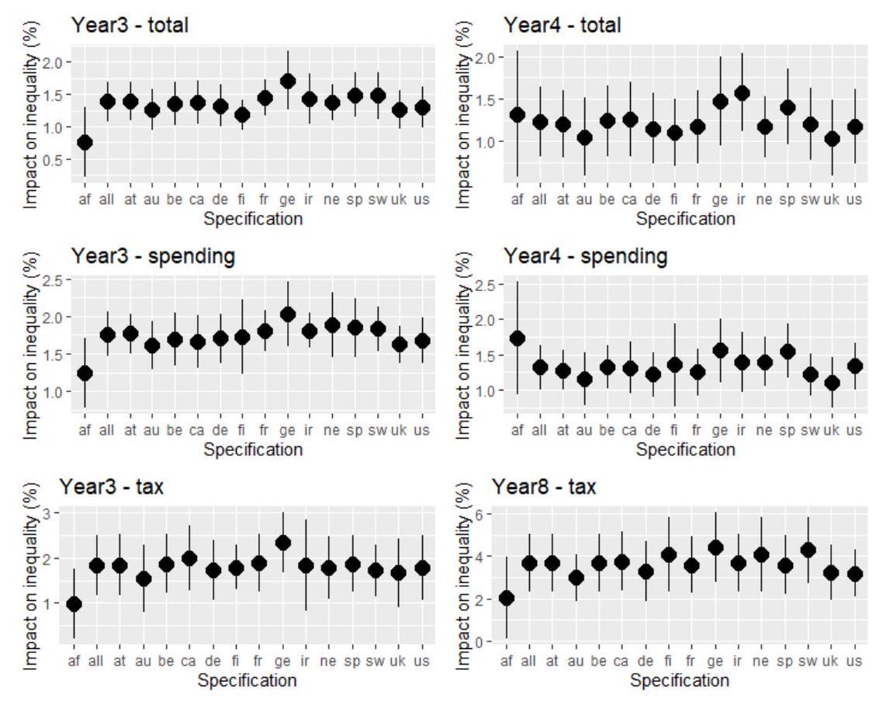
- Source: Author's calculations. We present the coefficients with one standard deviation band around them. "all" includes all countries (baseline), "af" excludes Australia, Finland, Denmark and the Netherlands, "at" excludes Austria, "au" excludes Australia, "be": excludes Belgica, "ca": excludes Canada, "de": excludes Denmark, "fi" excludes Finland, "fr" excludes France, "ge" excludes Germany, "ir" excludes Ireland, "ne" excludes Netherlands, "sp" excludes Spain, "sw" excludes Sweden, "uk" excludes the United Kingdom, "us" excludes the United States.

Fig.13B Impact of fiscal consolidation (of 1% of GDP) on earnings inequality 5010 - Different lags of the fiscal shock
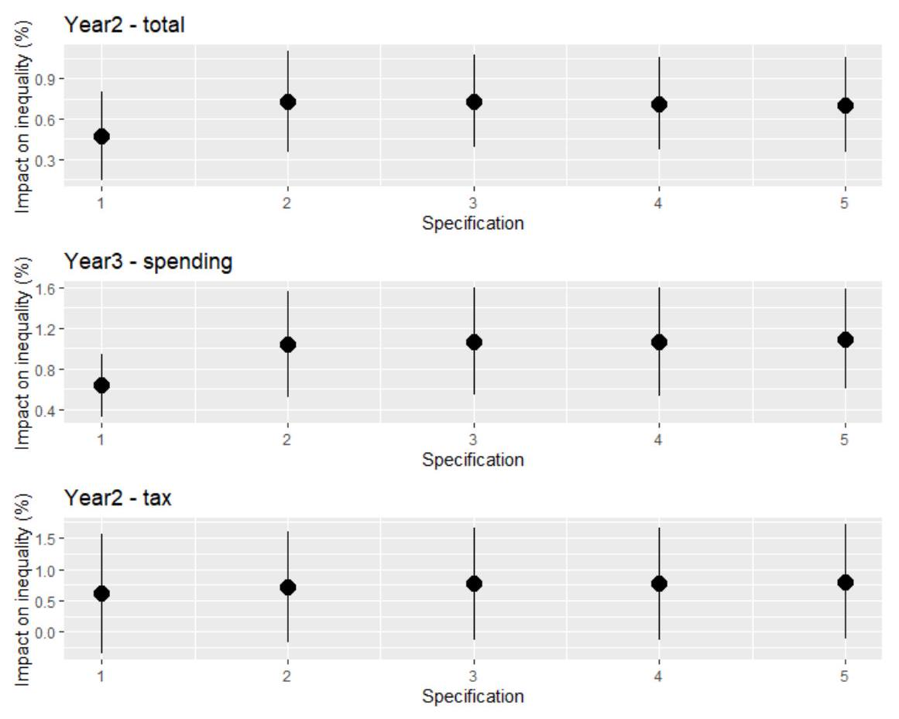
Source: Author's calculations. We present the coefficients with one standard deviation band around them. The baseline includes three lags and refers to “3” in the graph.
Fig.14B Impact of fiscal consolidation (of 1% of GDP) on earnings inequality 5010 - Different lags of the inequality measure
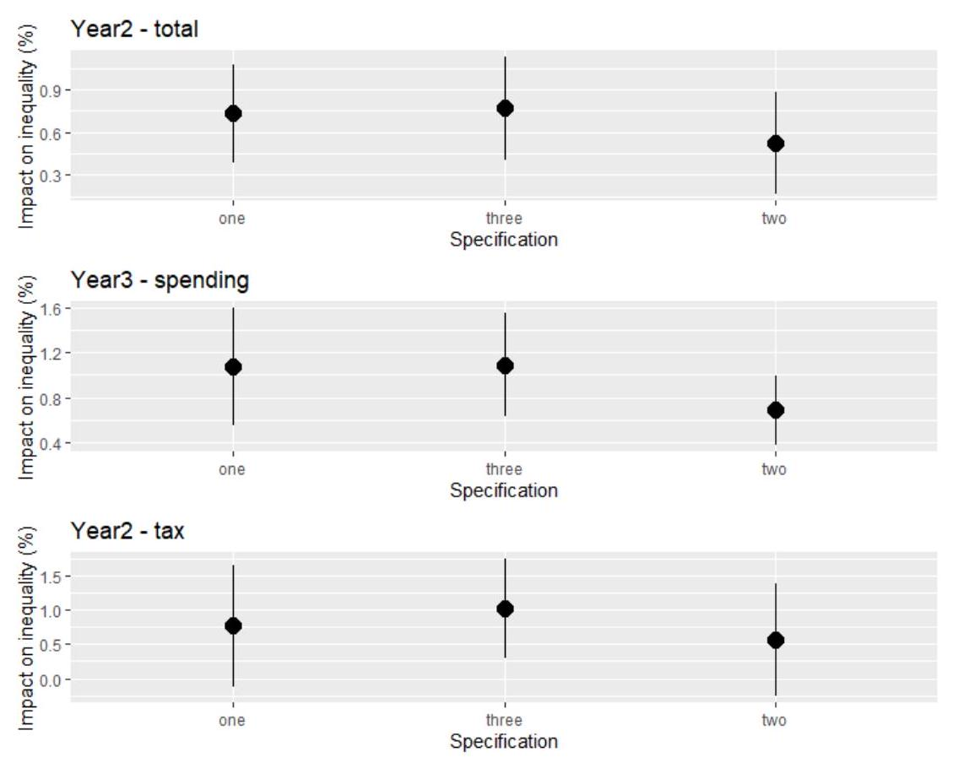
Source: Author's calculations. We present the coefficients with one standard deviation band around them. The baseline includes one lag and refers to “1” in the graph.
Fig.15B Impact of fiscal consolidation (of 1% of GDP) on earnings inequality 5010 - Different control variables
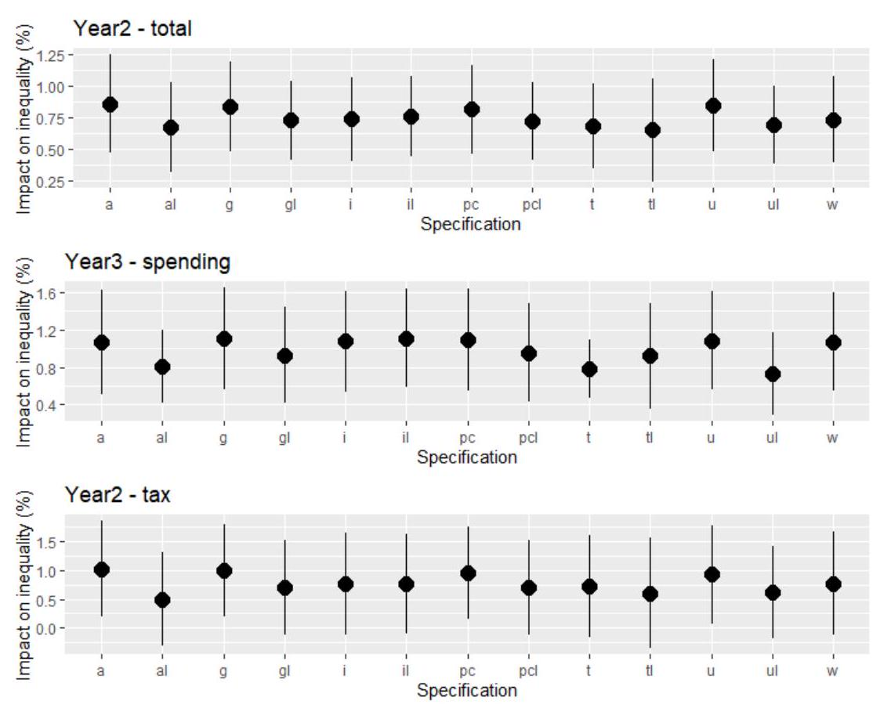
Source: Author's calculations. We present the coefficients with one standard deviation band around them. "a": all variables (all control variables are included), "g": real GDP growth rate, " i ": inflation rate, "pc": real GDP per capita, " t ": trade-to-GDP (openness), " u ": unemployment rate, "w": without control variables (baseline). "al", " gl ", " $il"$, "pcl", "tl" and "ul" control for the same variables, but adding one lag.

Fig.16B Impact of fiscal consolidation (of 1% of GDP) on earnings inequality 5010- Different countries
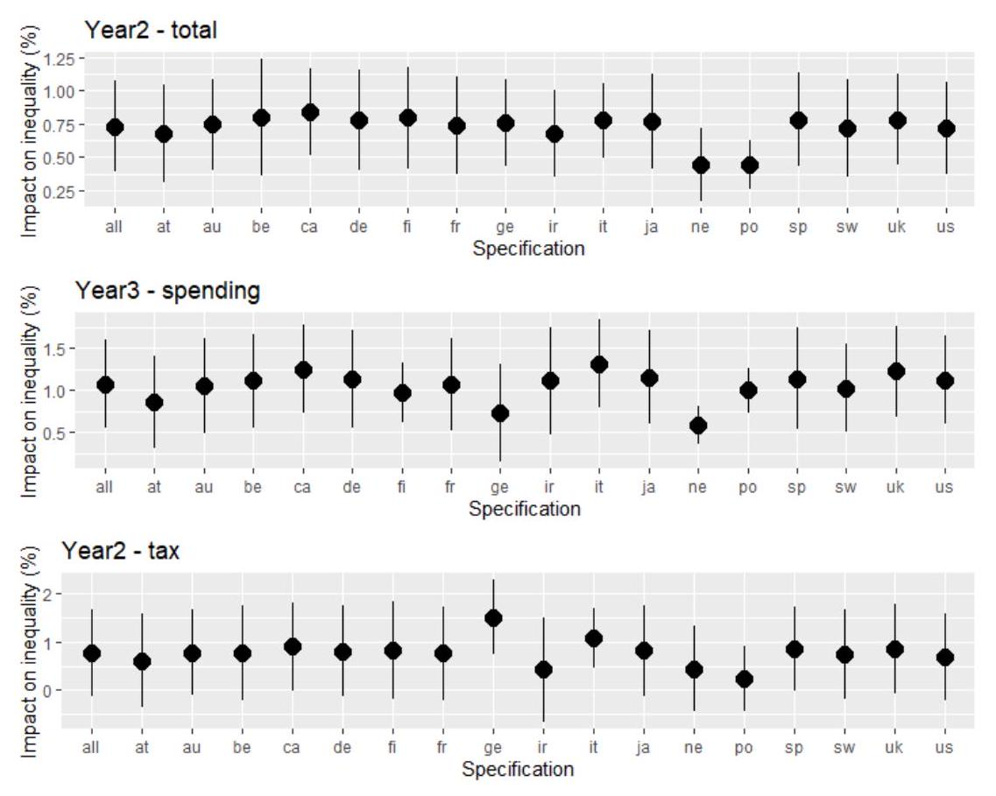
- Source: Author's calculations. We present the coefficients with one standard deviation band around them. "all" includes all countries (baseline), "at" excludes Austria, "au" excludes Australia, "be": excludes Belgium, "ca": excludes Canada, "de": excludes Denmark, "fi" excludes Finland, "fr" excludes France, "ge" excludes Germany, "ir" excludes Ireland, "it" includes Italy, "ja" excludes Japan, "ne" includes Netherlands, "po" excludes Portugal, "sp" includes Spain, "sw" excludes Sweden, "uk" excludes the United Kingdom, "us" excludes the United States.

Fig.17B Impact of fiscal consolidation (of 1% of GDP) on earnings inequality 5010 - Interpolation
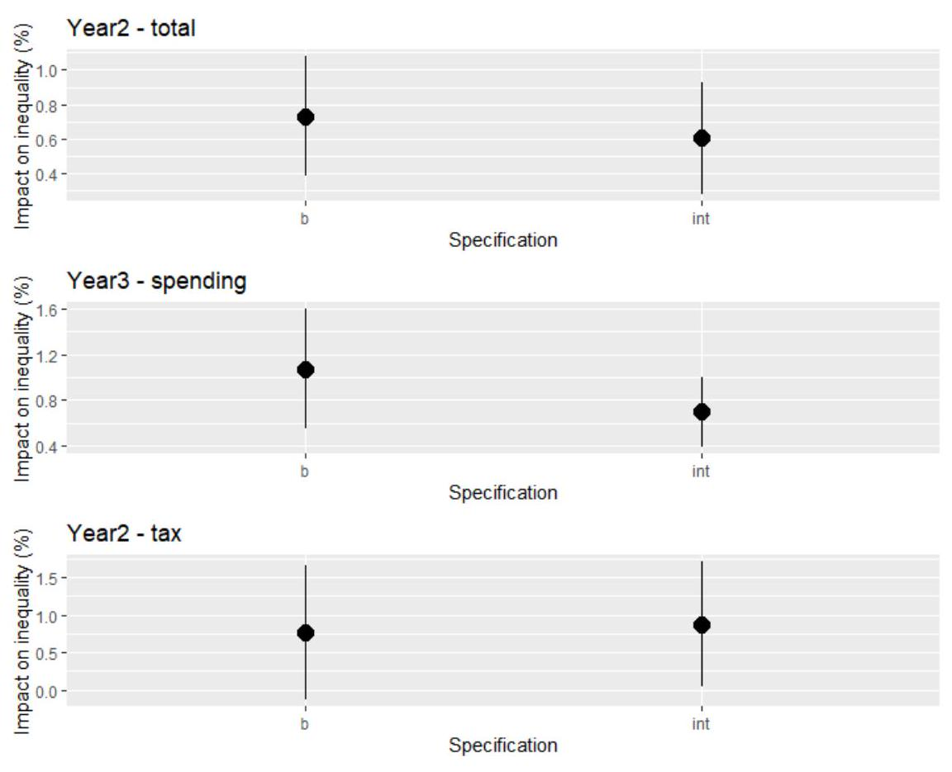
Source: Author's calculations. We present the coefficients with one standard deviation band around them. The baseline is represented by “b”, while “int” means the interpolated database.
Fig.18B Impact of fiscal consolidation (of 1% of GDP) on earnings inequality 9050 - Different lags of the fiscal shock
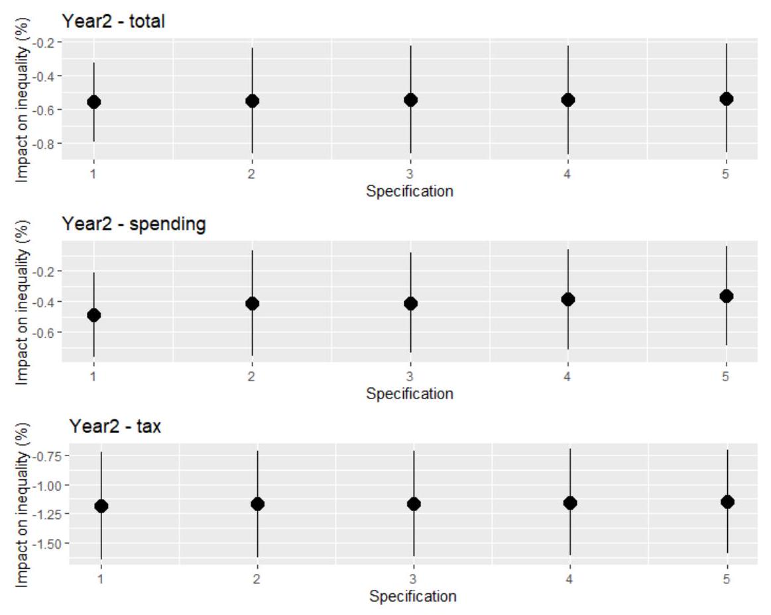
Source: Author's calculations. We present the coefficients with one standard deviation band around them. The baseline includes one lag and refers to “1” in the graph.
Fig.19B Impact of fiscal consolidation (of 1% of GDP) on earnings inequality 9050 - Different lags of the inequality measure
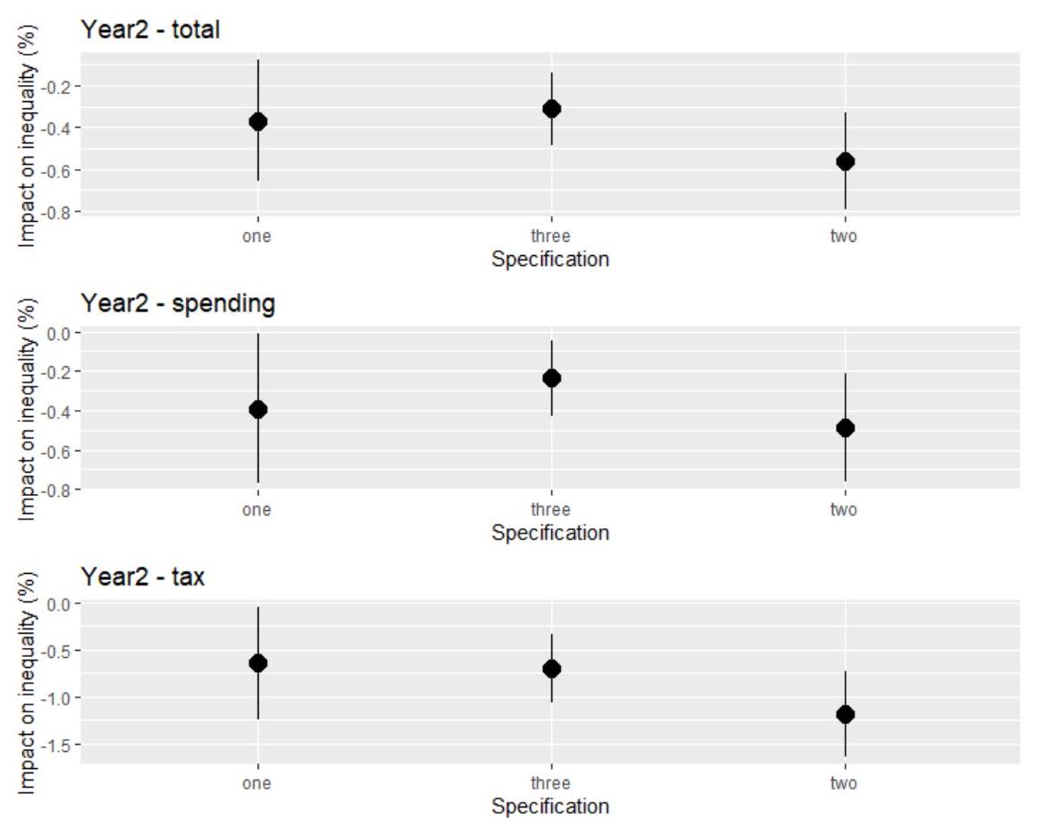
Source: Author's calculations. We present the coefficients with one standard deviation band around them. The baseline includes two lags and refers to “two” in the graph.

Fig.20B Impact of fiscal consolidation (of 1% of GDP) on earnings inequality 9050 - Different control variables
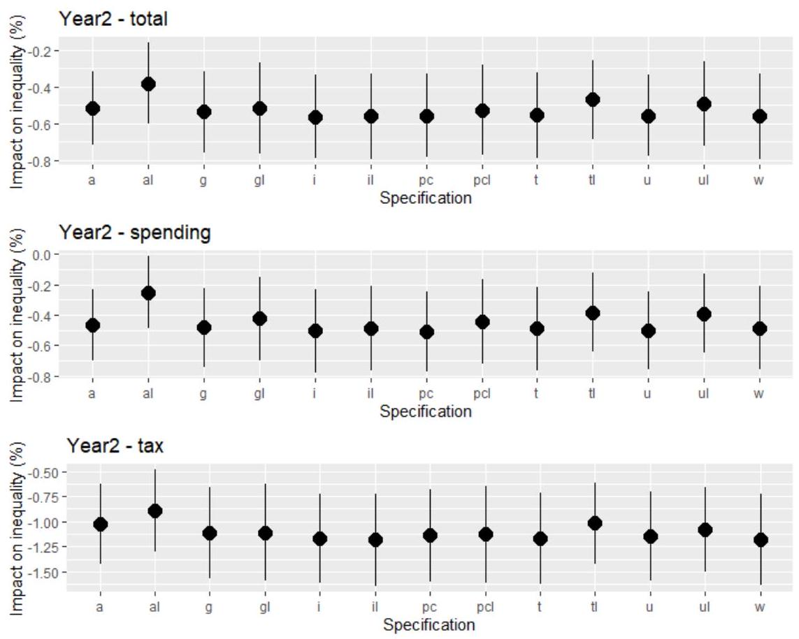
Source: Author's calculations. We present the coefficients with one standard deviation band around them. "a": all variables (all control variables are included), "g": real GDP growth rate, " i ": inflation rate, "pc": real GDP per capita, " t ": trade-to-GDP (openness), " u ": unemployment rate, "w": without control variables (baseline). "al", " gl ", " $il"$, "pcl", "tl" and "ul" control for the same variables, but adding one lag.

Fig.21B Impact of fiscal consolidation (of 1% of GDP) on earnings inequality 9050 - Different countries
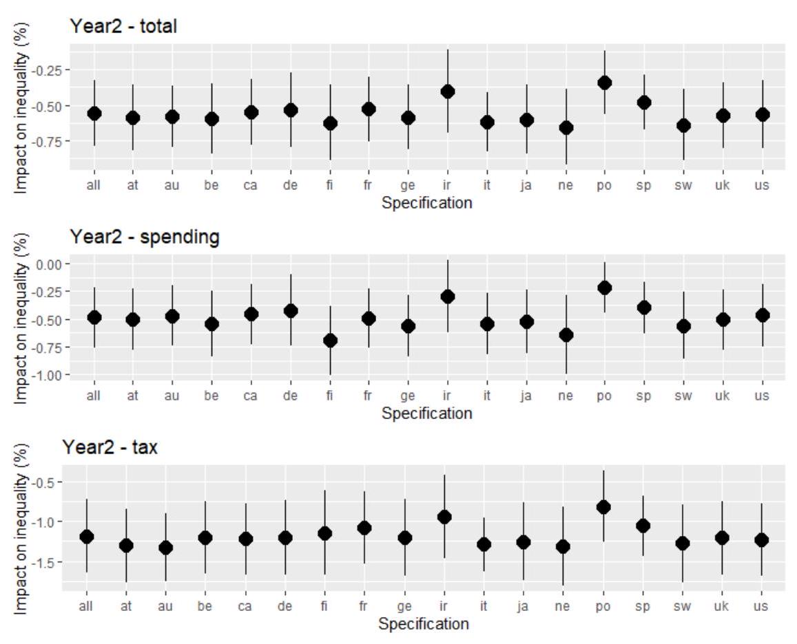
Source: Author's calculations. We present the coefficients with one standard deviation band around them. "all" includes all countries (baseline), "at" excludes Austria, "au" excludes Australia, "be": excludes Belgium, "ca": excludes Canada, "de": excludes Denmark, "fi" excludes Finland, "fr" excludes France, "ge" excludes Germany, "ir" excludes Ireland, "it" includes Italy, "ja" excludes Japan, "ne" excludes Netherlands, "po" excludes Portugal, "sw" excludes Sweden, "sp" includes Spain, "uk" excludes the United Kingdom, "us" excludes the United States.

Fig.22B Impact of fiscal consolidation (of 1% of GDP) on earnings inequality 9050- Interpolation
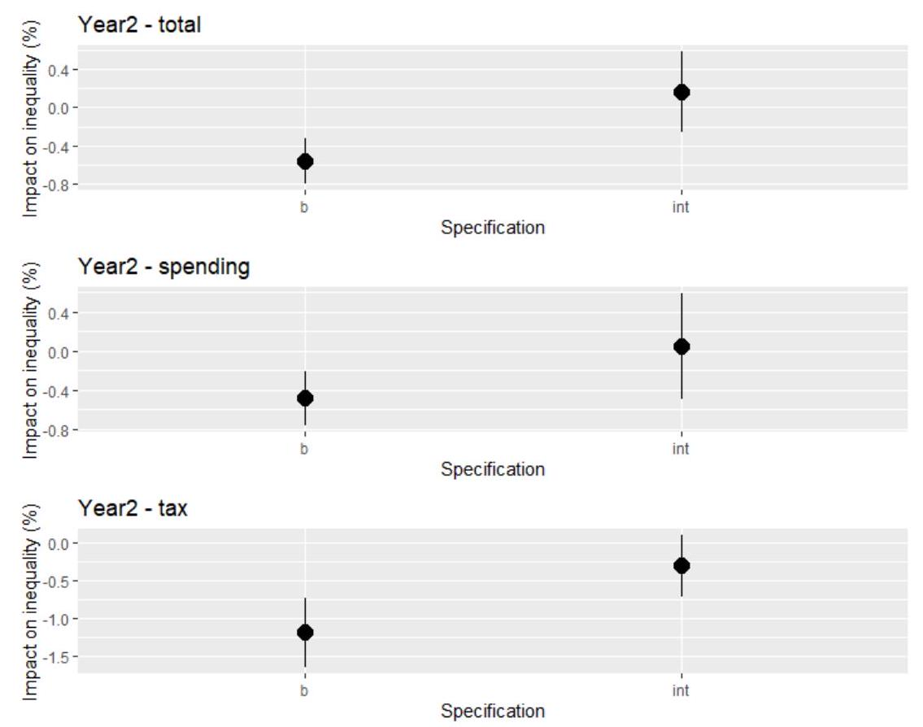
- Source: Author's calculations. We present the coefficients with one standard deviation band around them. The baseline is represented by "b" while "int" means the interpolated database.

Fig.23B Impact of fiscal consolidation (of 1% of GDP) on earnings inequality 9010- Different lags of the fiscal shock
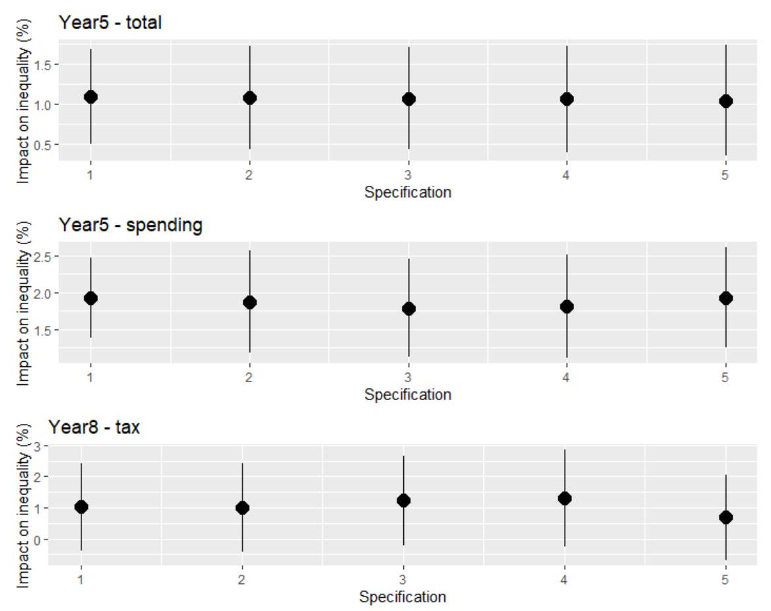
Source: Author's calculations. We present the coefficients with one standard deviation band around them. The baseline includes one lag and refers to “1” in the graph.
Fig.24B Impact of fiscal consolidation (of 1% of GDP) on earnings inequality 9010- Different lags of the inequality measure
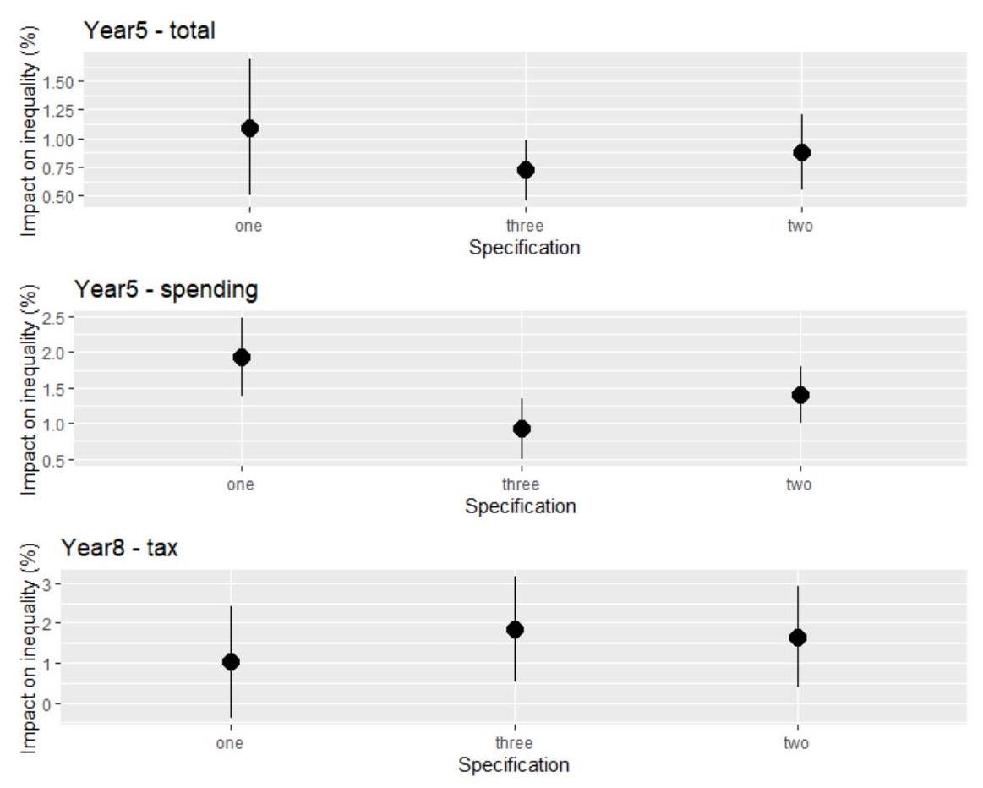
Source: Author's calculations. We present the coefficients with one standard deviation band around them. The baseline includes one lag and refers to "one" in the graph.
Fig.25B Impact of fiscal consolidation (of 1% of GDP) on earnings inequality 9010- Different control variables
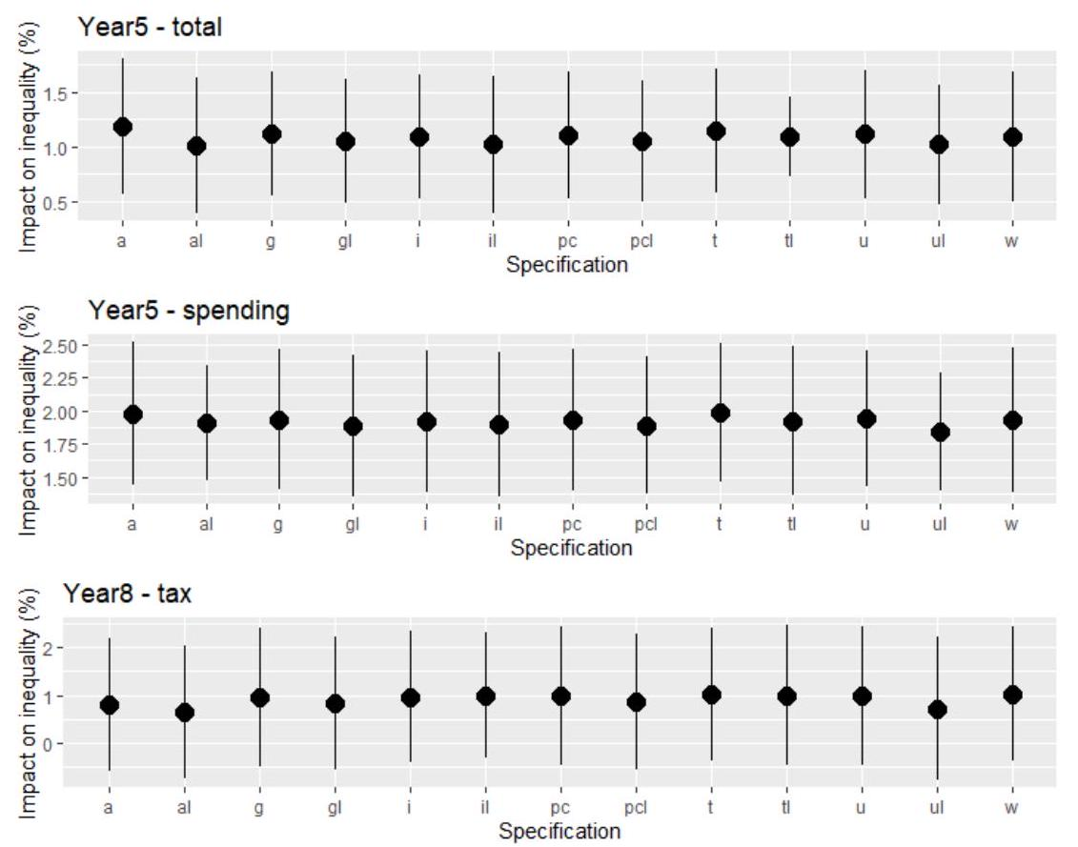
Source: Author's calculations. We present the coefficients with one standard deviation band around them. "a": all variables (all control variables are included), "g": real GDP growth rate, "i": inflation rate, "pc": real GDP per capita, "t": trade-to-GDP (openness), "u": unemployment rate, "w": without control variables (baseline). "al", "gl", "il", "pcl", "tl" and "ul" control for the same variables, but adding one lag.

Fig.26B Impact of fiscal consolidation (of 1% of GDP) on earnings inequality 9010 - Different countries
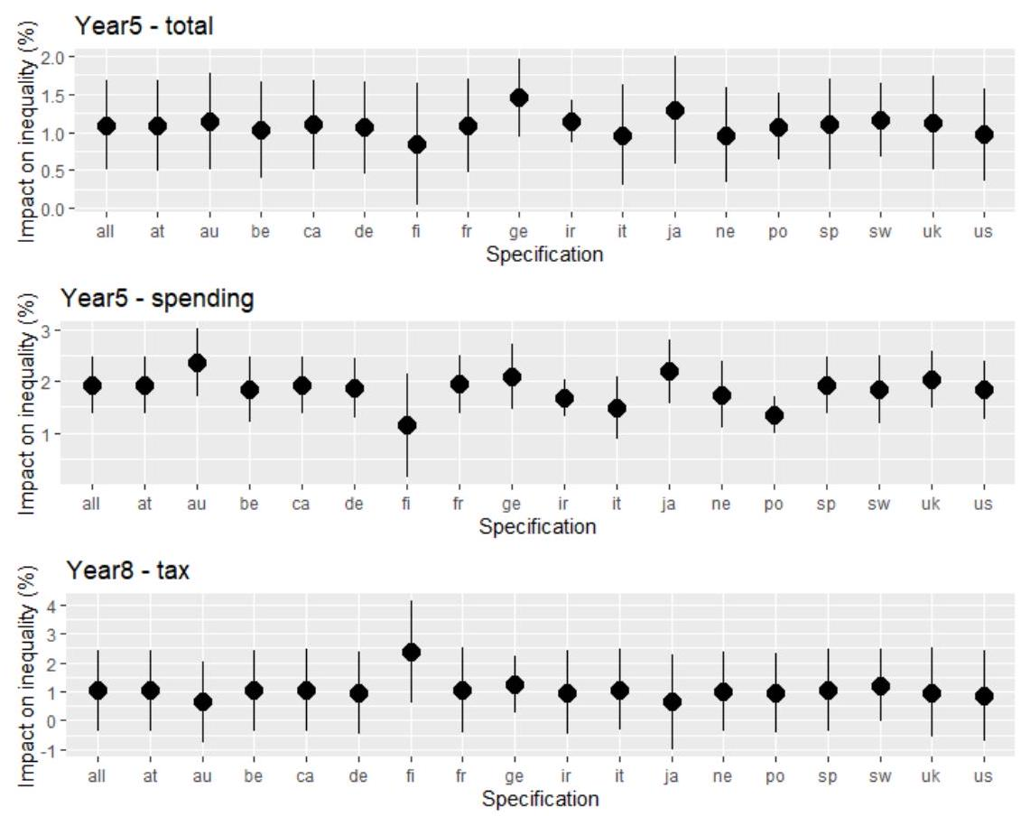
- Source: Author's calculations. We present the coefficients with one standard deviation band around them. "all" includes all countries (baseline), "at" excludes Austria, "au" excludes Australia, "be": excludes Belgium, "ca": excludes Canada, "de": excludes Denmark, "fi" excludes Finland, "fr" excludes France, "ge" excludes Germany, "ir" excludes Ireland, "it" includes Italy, "ja" excludes Japan, "ne" includes Netherlands, "po" includes Portugal, "sp" includes Spain, "sw" excludes Sweden, "uk" excludes the United Kingdom, "us" excludes the United States.

Fig.27B Impact of fiscal consolidation (of 1% of GDP) on earnings inequality 9010- Interpolation
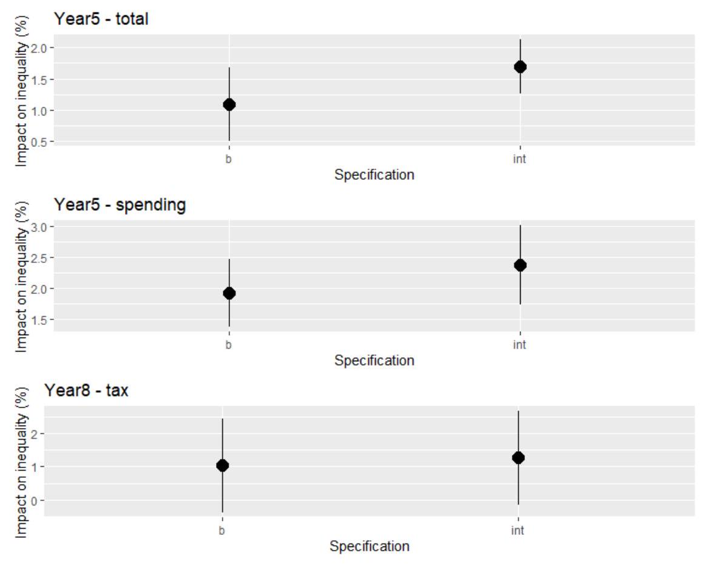
Source: Author's calculations. We present the coefficients with one standard deviation band around them. The baseline is represented by "b", while "int" means the interpolated database.

Fig.28B Impact of fiscal consolidation (of 1% of GDP) on the labor share - Different lags of the fiscal shock
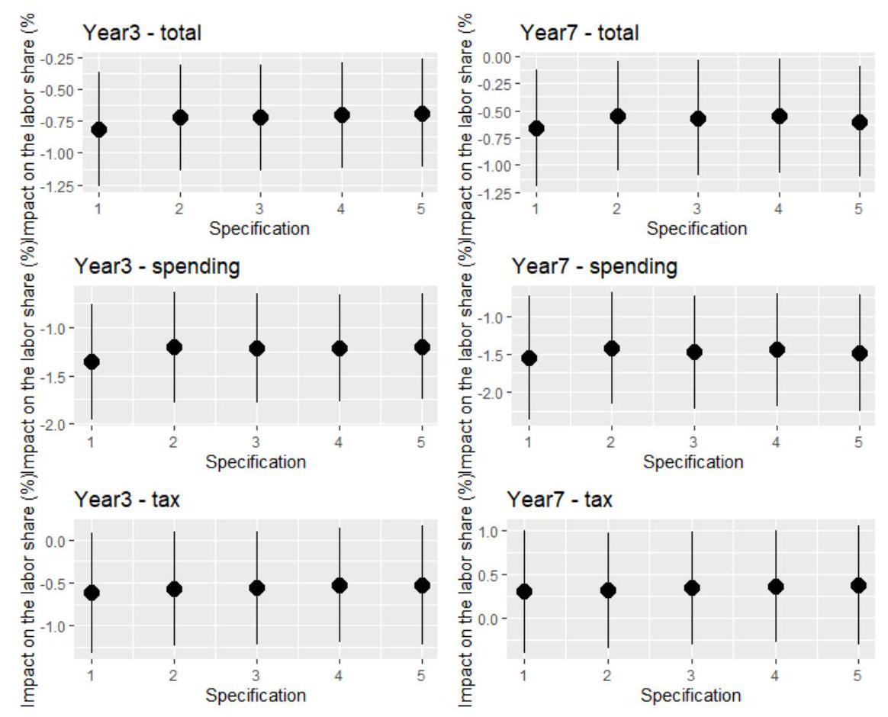
Source: Author's calculations. We present the coefficients with one standard deviation band around them. The baseline includes one lag and refers to “1” in the graph.
Fig.29B Impact of fiscal consolidation (of 1% of GDP) on the labor share - Different lags of the labor share
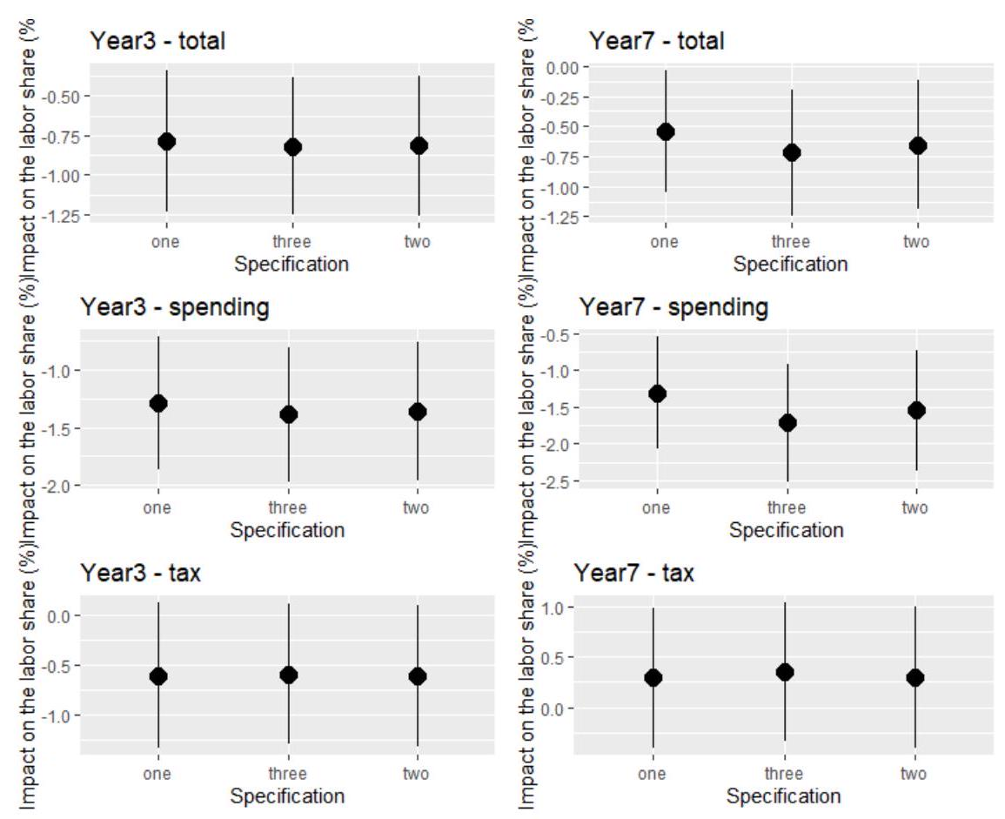
Source: Author's calculations. We present the coefficients with one standard deviation band around them. The baseline includes two lags and refers to “two” in the graph.
Fig.30B Impact of fiscal consolidation (of 1% of GDP) on the labor share - Different control variables
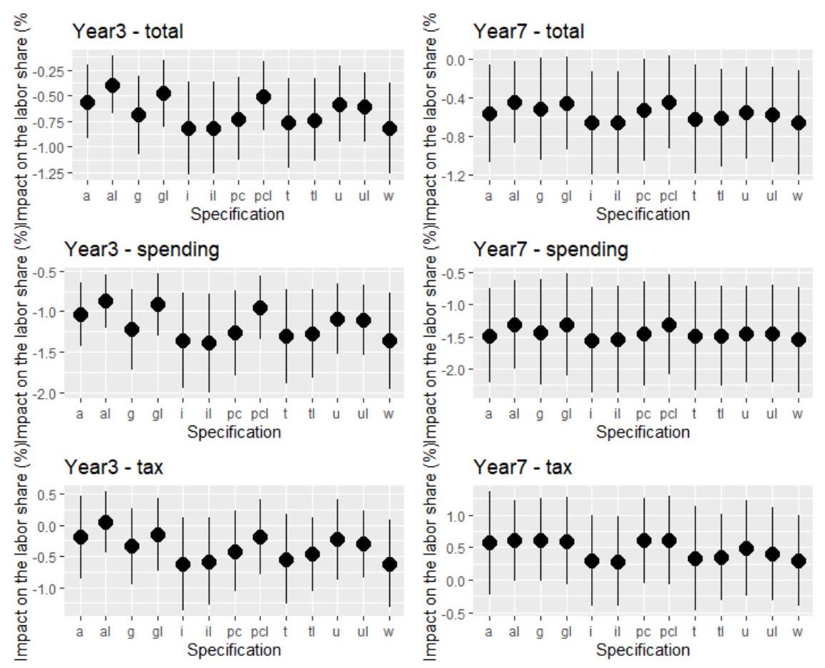
- Source: Author's calculations. We present the coefficients with one standard deviation band around them. "a": all variables (all control variables are included), "g": real GDP growth rate, " i ": inflation rate, "pc": real GDP per capita, " t ": trade-to-GDP (openness), " u ": unemployment rate, "w": without control variables (baseline). "al", "gl", "il", "pcl", "tl" and "ul" control for the same variables, but adding one lag.

Fig.31B Impact of fiscal consolidation (of 1% of GDP) on the labor share - Different countries
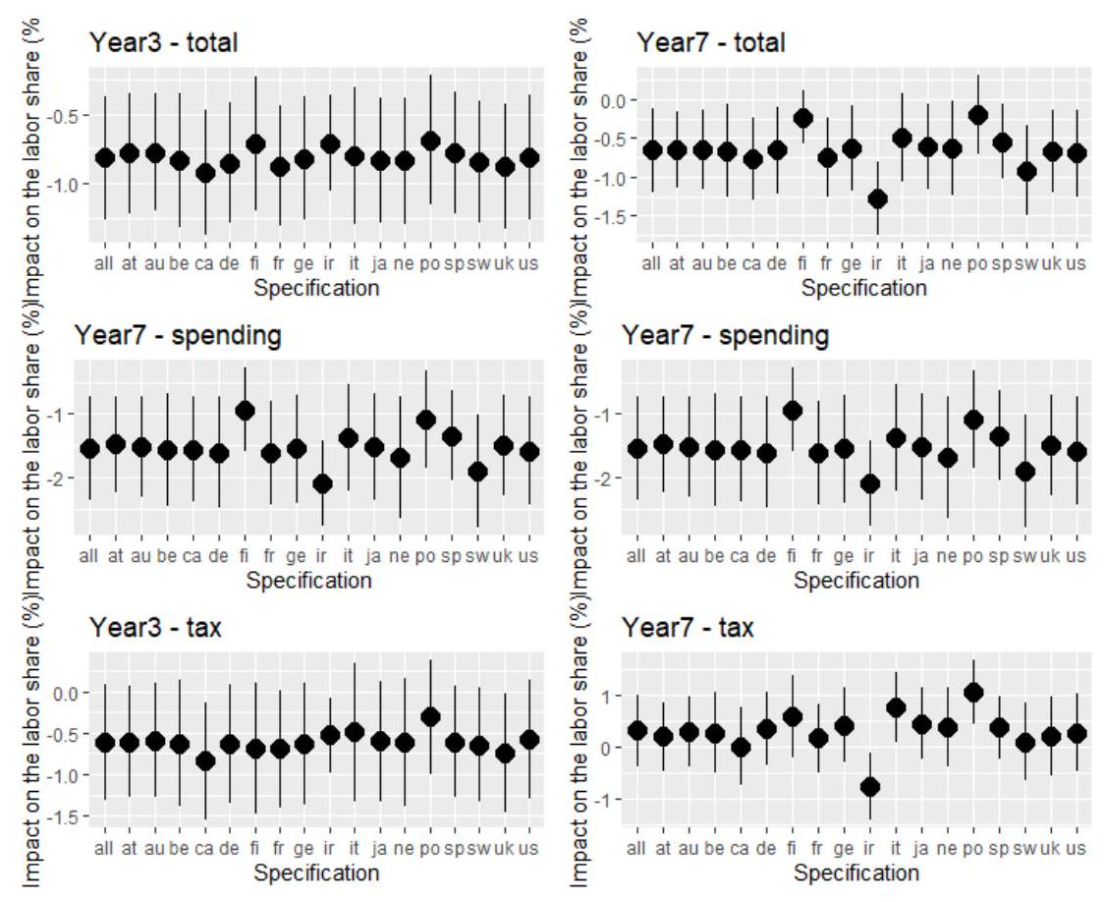
Source: Author's calculations. We present the coefficients with one standard deviation band around them. "all" includes all countries (baseline), "at" includes Austria, "au" excludes Australia, "be": excludes Belgium, "ca": excludes Canada, "de": excludes Denmark, "fi" excludes Finland, "fr" excludes France, "ge" excludes Germany, "ir" excludes Ireland, "it" excludes Italy, "ja" excludes Japan, "ne" excludes Netherlands, "po" excludes Portugal, "sp" includes Spain, "sw" excludes Sweden, "uk" excludes the United Kingdom, "us" excludes the United States.

Fig.32B Cumulative Response of Disposable Income Inequality (change in %) to a fiscal consolidation of 1% of GDP - Three types of fiscal shock (total, spending-based and tax-based) - Robustness test - Estimations using Devries et al. 2011 (1978-2009) and Alesina et al. 2019 (2010-2014)
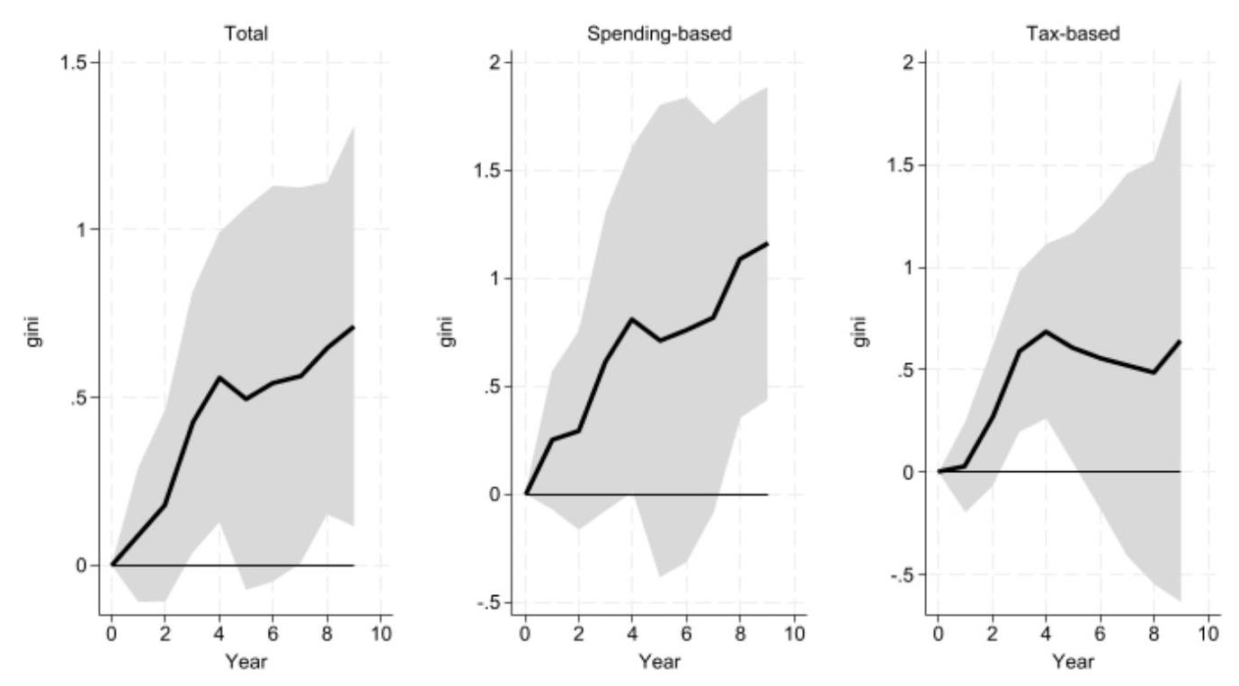
Source: Author's calculations.
Fig.33B Cumulative Response of Market Income Inequality (change in %) to a fiscal consolidation of 1% of GDP - Three types of fiscal shock (total, spending-based and tax-based) - Robustness test - Estimations using Devries et al. 2011 (1978-2009) and Alesina et al. 2019 (2010-2014)
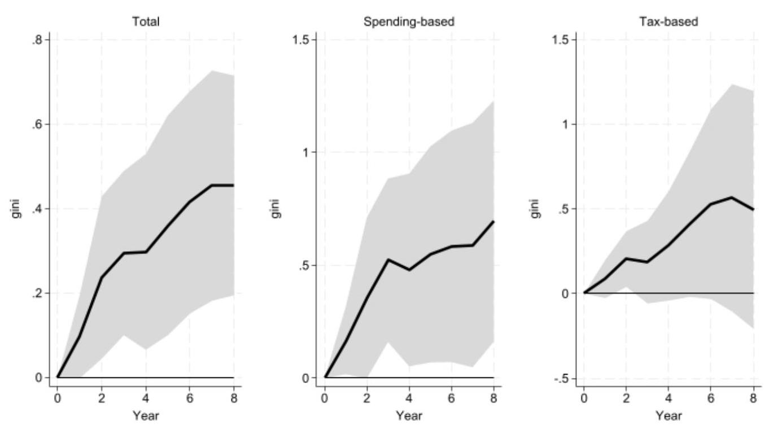
Source: Author's calculations.

Fig.34B Cumulative Response of Gross Wage Inequality (change in %) to a fiscal consolidation of 1% of GDP - Three types of fiscal shock (total, spending-based and tax-based) - Robustness test - Estimations using Devries et al. 2011 (1978-2009) and Alesina et al. 2019 (2010-2014)
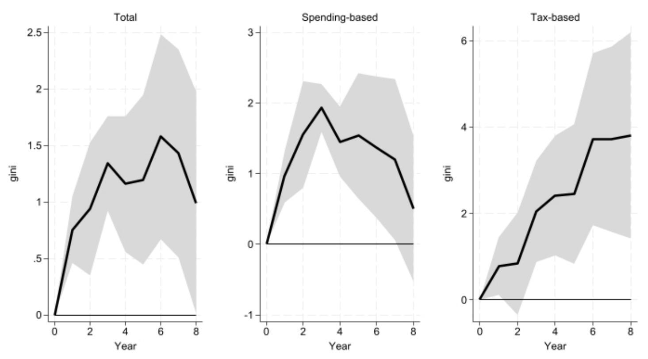
Source: Author's calculations.
Fig.35B Cumulative Response of the Percentile Ratio 50/10 of Gross Earnings (change in %) to a fiscal consolidation of 1% of GDP - Three types of fiscal shock (total, spending-based and tax-based) - Robustness test - Estimations using Devries et al. 2011 (1978-2009) and Alesina et al. 2019 (2010-2014)
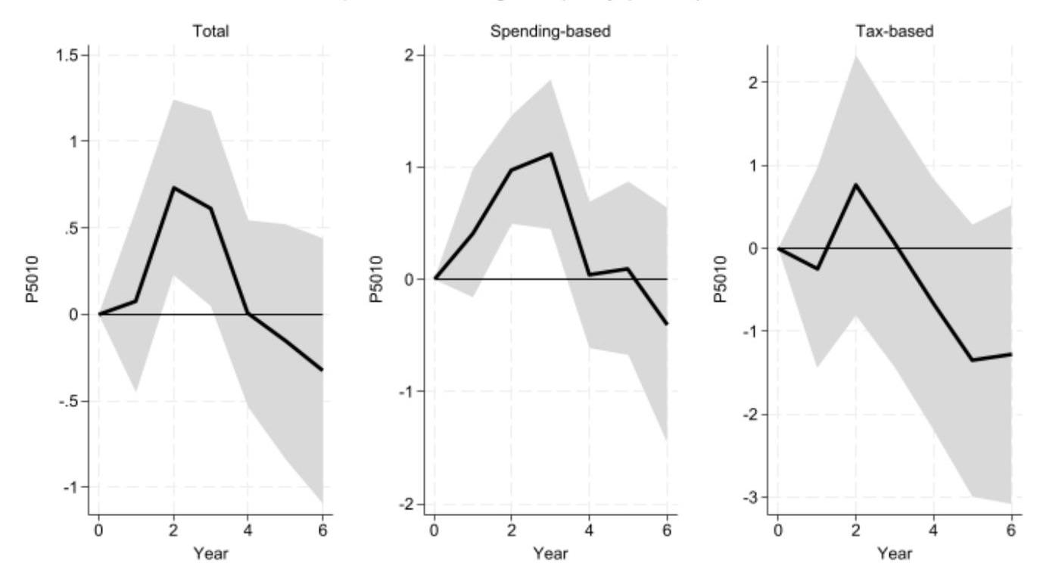
Source: Author's calculations.
Fig.36B Cumulative Response of the Percentile Ratio 90/50 of Gross Earnings (change in %) to a fiscal consolidation of 1% of GDP - Three types of fiscal shock (total, spending-based and tax-based) - Robustness test - Estimations using Devries et al. 2011 (1978-2009) and Alesina et al. 2019 (2010-2014)
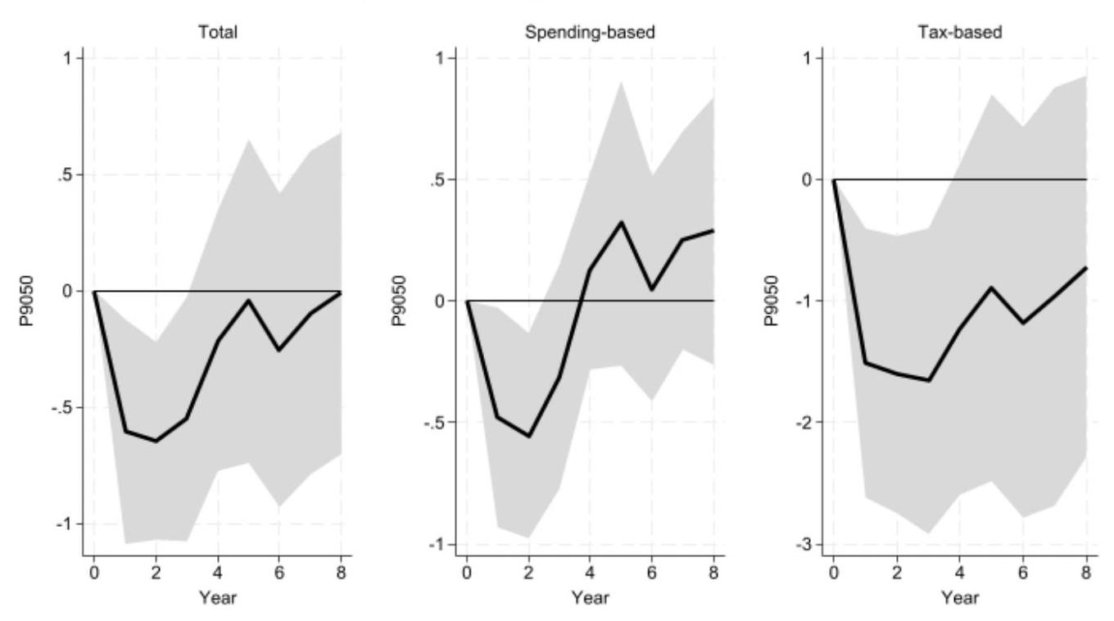
Source: Author's calculations.
Fig.37B Cumulative Response of the Percentile Ratio 90/10 of Gross Earnings (change in %) to a fiscal consolidation of 1% of GDP - Three types of fiscal shock (total, spending-based and tax-based) - Robustness test - Estimations using Devries et al. 2011 (1978-2009) and Alesina et al. 2019 (2010-2014)
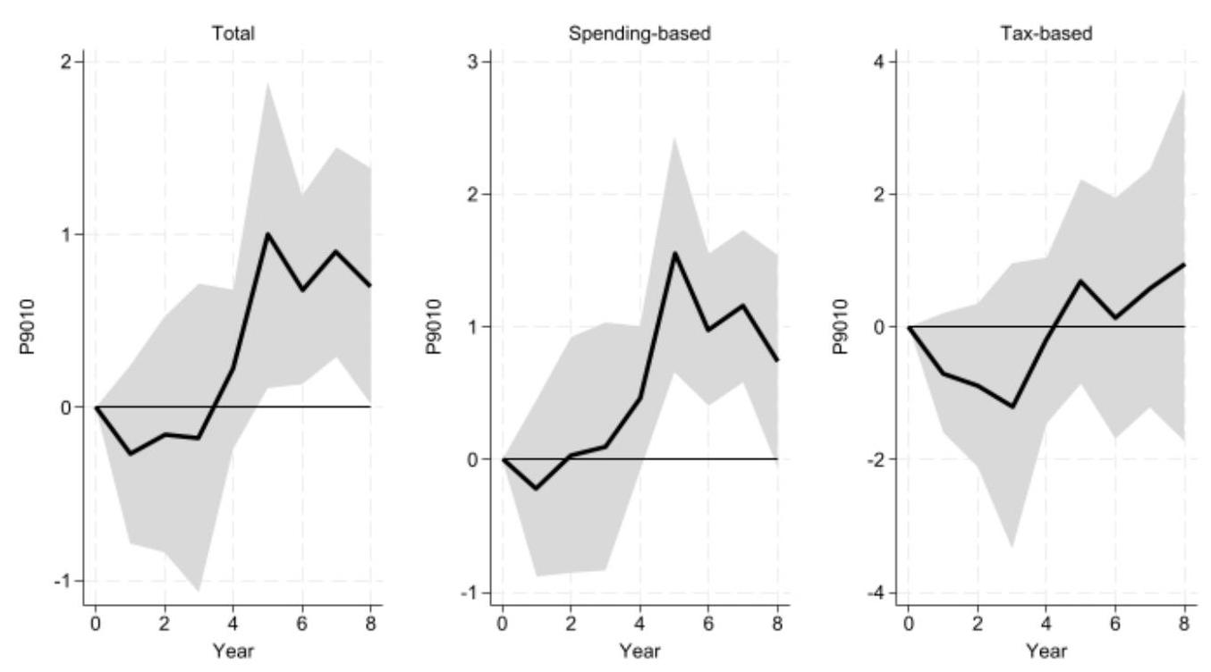
Source: Author's calculations.
Fig.38B Cumulative Response of the Labor Share in Income (change in %) to a fiscal consolidation of 1% of GDP - Three types of fiscal shock (total, spending-based and tax-based) - Robustness test - Estimations using Devries et al. 2011 (1978-2009) and Alesina et al. 2019 (2010-2014)
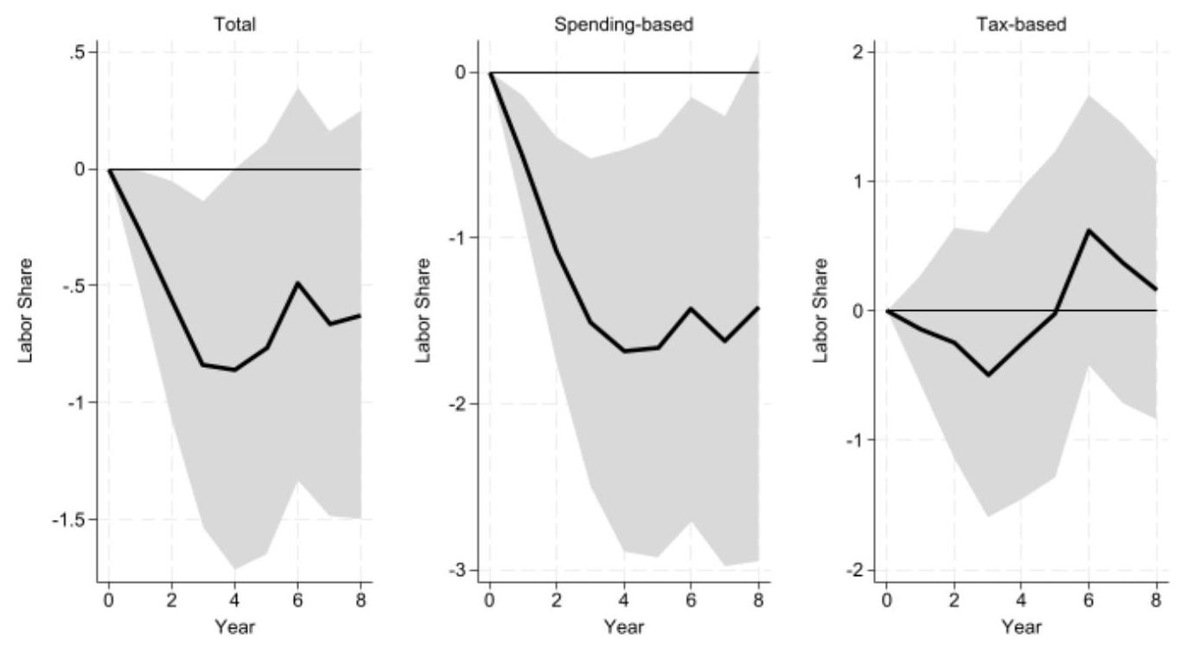
Source: Author's calculations.
Fig.39B Cumulative Response of Disposable Income Inequality (change in %) to a fiscal consolidation of 1% of GDP - Three types of fiscal shock (total, spending-based and tax-based) - Robustness test – Estimations using Gupta et al. (2017): Devries et al., 2011 (1978-2009), Alesina et al., 2015 (2010-2013), Gupta et al., 2017 (2014)
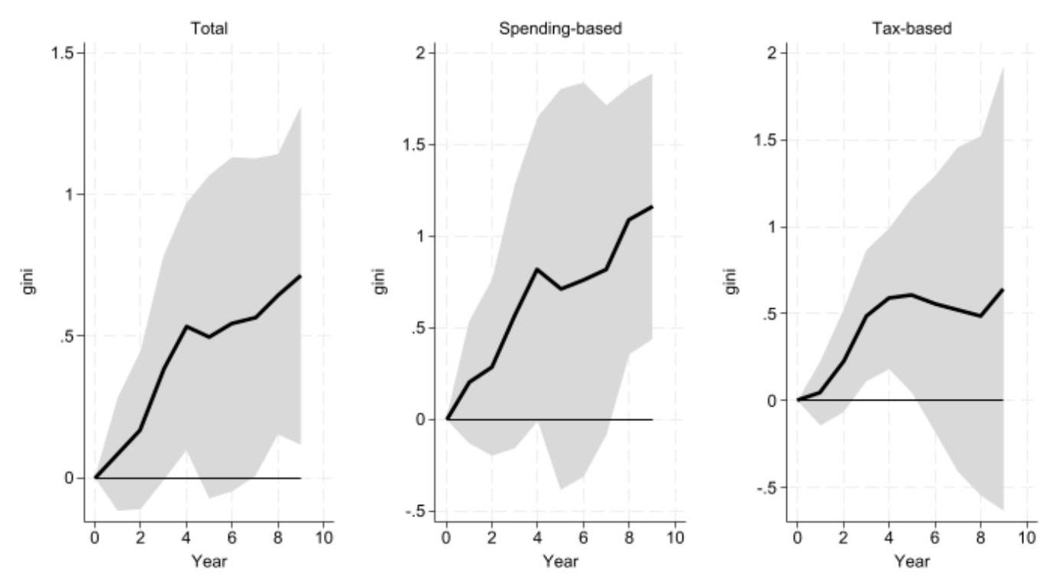
Source: Author's calculations.
Fig.40B Cumulative Response of Market Income Inequality (change in %) to a fiscal consolidation of 1% of GDP - Three types of fiscal shock (total, spending-based and tax-based) - Robustness test – Estimations using Gupta et al. (2017): Devries et al., 2011 (1978-2009), Alesina et al., 2015 (2010-2013), Gupta et al., 2017 (2014)
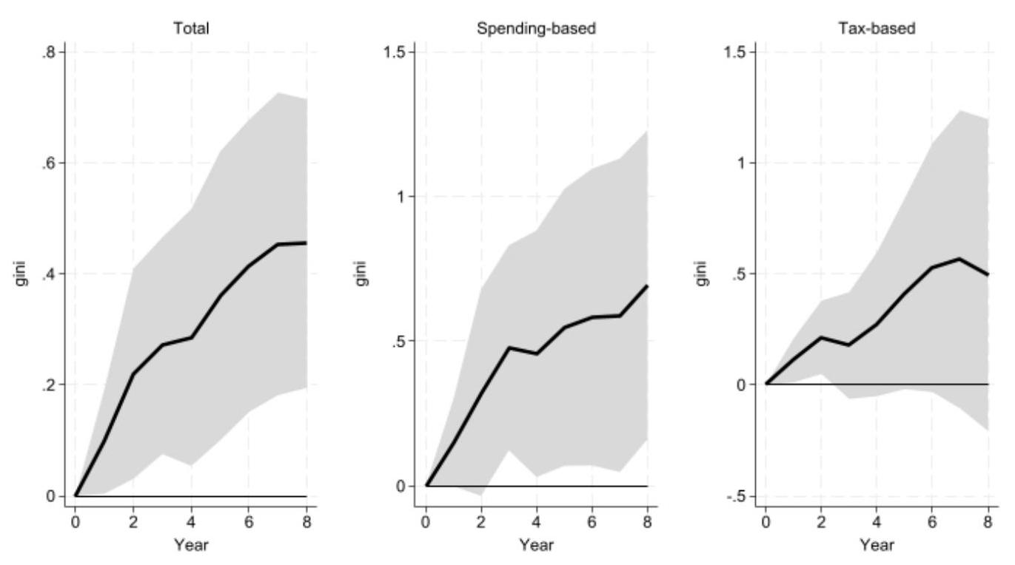
Source: Author's calculations.
Fig.41B Cumulative Response of Gross Wage Inequality (change in %) to a fiscal consolidation of 1% of GDP - Three types of fiscal shock (total, spending-based and tax-based) - Robustness test – Estimations using Gupta et al. (2017): Devries et al., 2011 (1978-2009), Alesina et al., 2015 (2010-2013), Gupta et al., 2017 (2014)
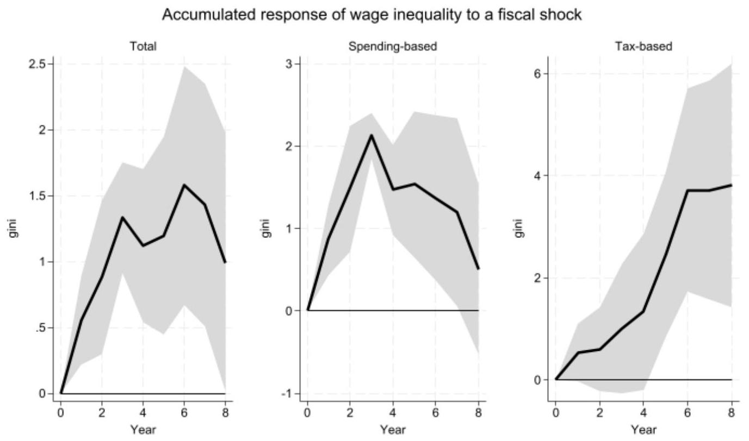
Source: Author's calculations.
Fig.42B Cumulative Response of the Percentile Ratio (50/10) of Gross Earnings (change in %) to a fiscal consolidation of 1% of GDP - Three types of fiscal shock (total, spending-based and tax-based) - Robustness test – Estimations using Gupta et al. (2017): Devries et al., 2011 (1978-2009), Alesina et al., 2015 (2010-2013), Gupta et al., 2017 (2014)
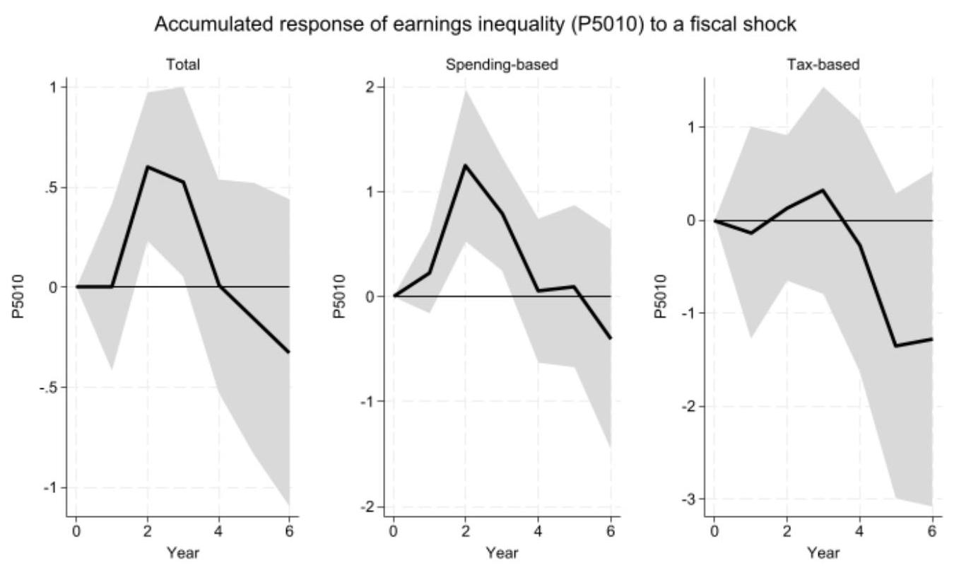
Source: Author's calculations.
Fig.43B Cumulative Response of the Percentile Ratio (90/50) of Gross Earnings (change in %) to a fiscal consolidation of 1% of GDP - Three types of fiscal shock (total, spending-based and tax-based) - Robustness test – Estimations using Gupta et al. (2017): Devries et al., 2011 (1978-2009), Alesina et al., 2015 (2010-2013), Gupta et al., 2017 (2014)
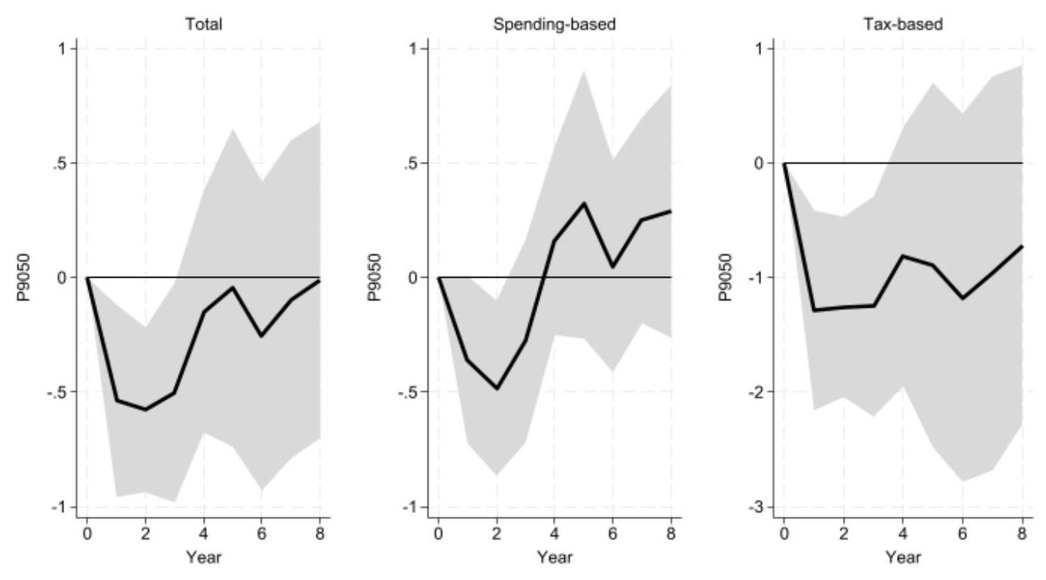
Source: Author's calculations.
Fig.44B Cumulative Response of the Percentile Ratio (90/10) of Gross Earnings (change in %) to a fiscal consolidation of 1% of GDP - Three types of fiscal shock (total, spending-based and tax-based) - Robustness test – Estimations using Gupta et al. (2017): Devries et al., 2011 (1978-2009), Alesina et al., 2015 (2010-2013), Gupta et al., 2017 (2014)
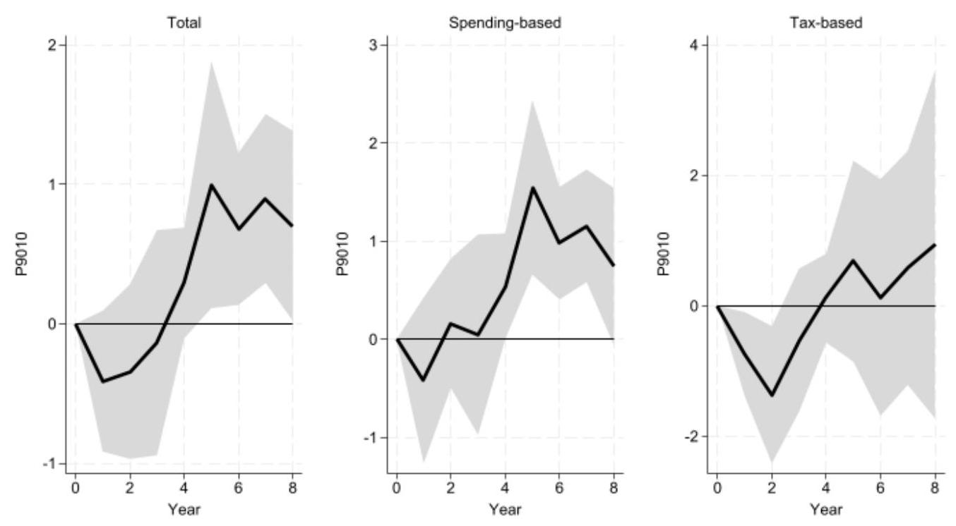
Source: Author's calculations.
Fig.45B Cumulative Response of the Labor Share in Income (change in %) to a fiscal consolidation of 1% of GDP - Three types of fiscal shock (total, spending-based and tax-based) - Robustness test – Estimations using Gupta et al. (2017): Devries et al., 2011 (1978-2009), Alesina et al., 2015 (2010-2013), Gupta et al., 2017 (2014)
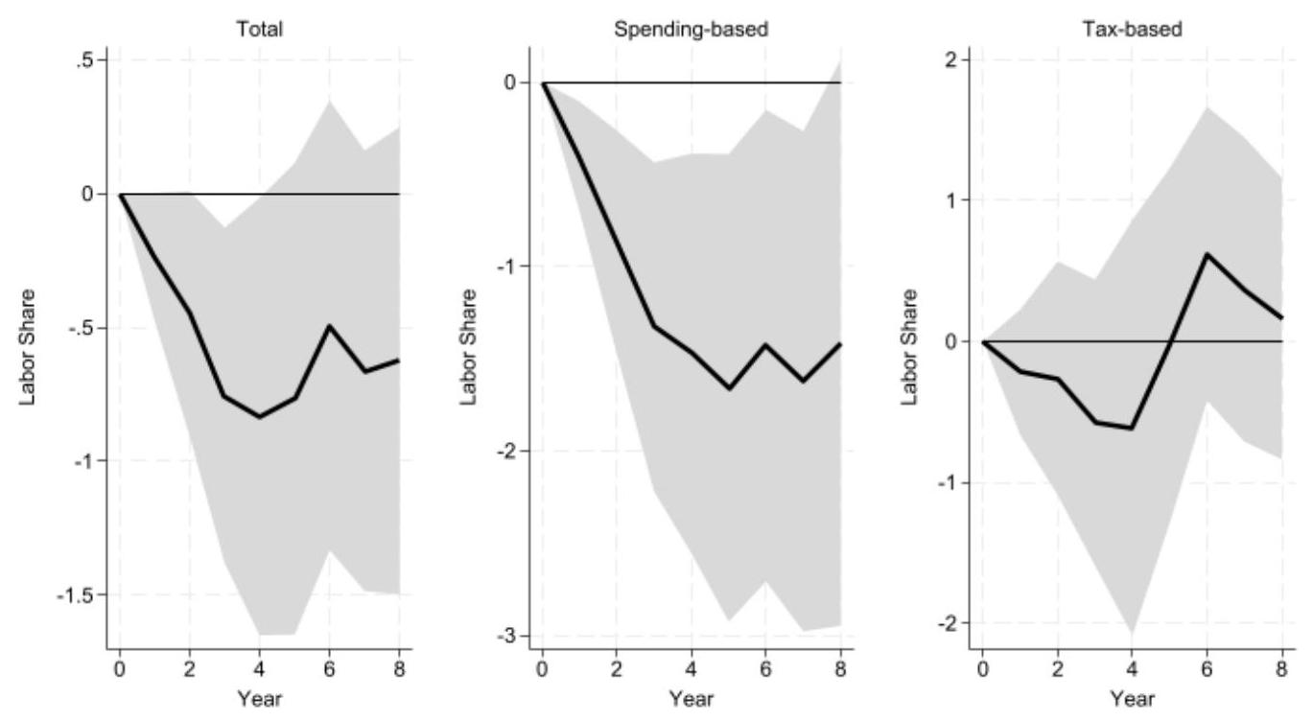
Source: Author's calculations.
Fig.46B Impact of fiscal consolidation (of 1% of GDP) on the redistribution measure- Different lags of the fiscal shock
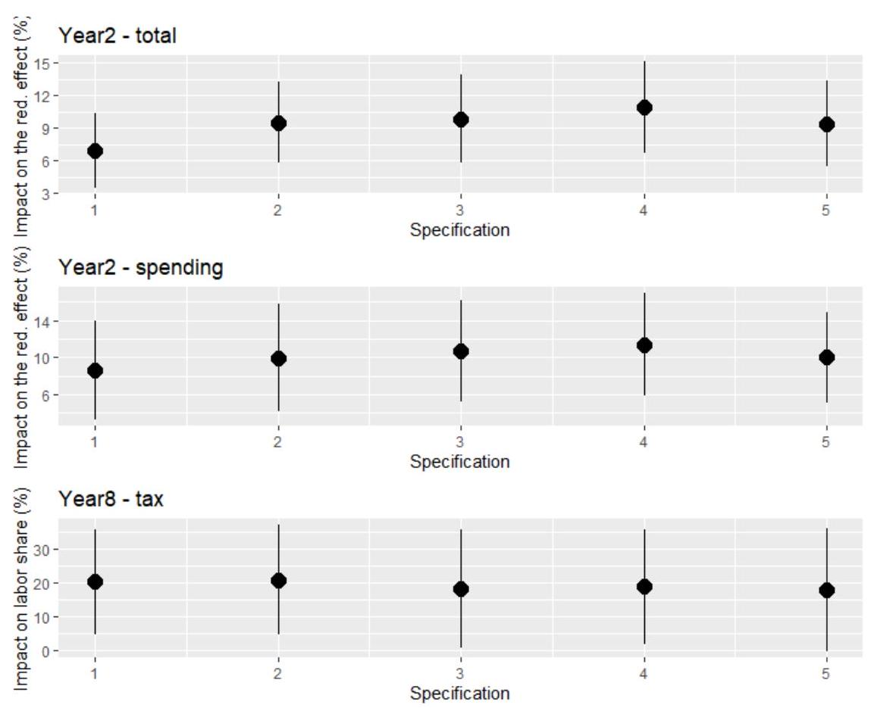
Source: Author's calculations. We present the coefficients with one standard deviation band around them. The baseline includes two lags and refers to "2" in the graph.
Fig.47B Impact of fiscal consolidation (of 1% of GDP) on the redistribution measure - Different lags of the redistribution measure
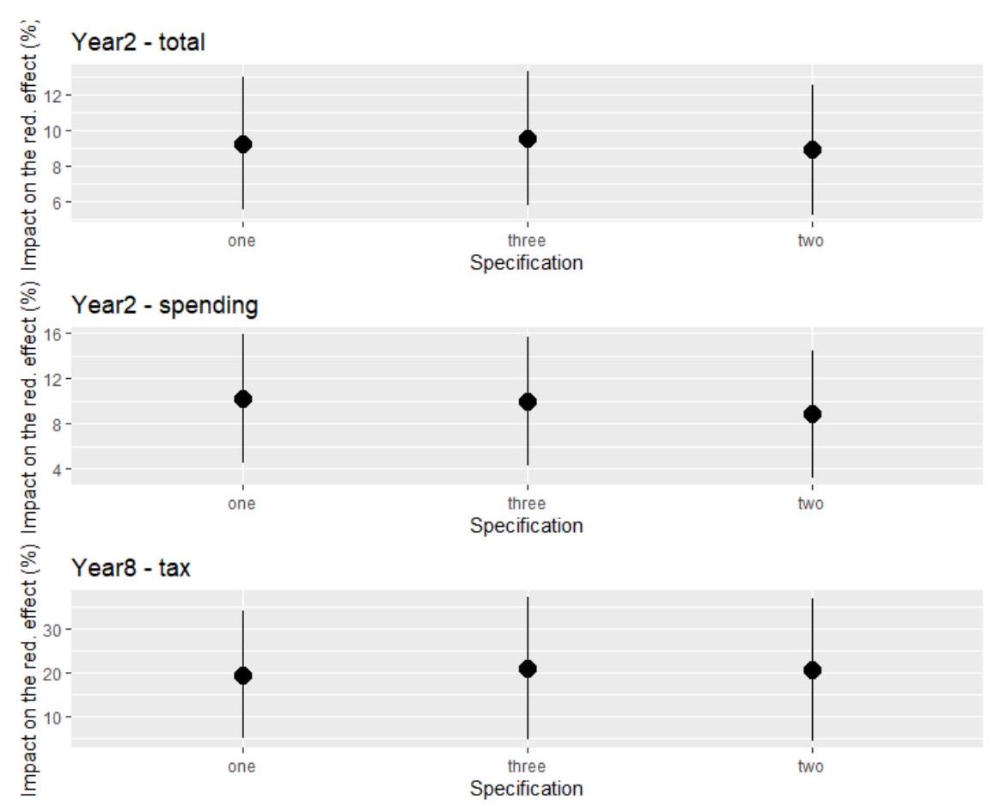
Source: Author's calculations. We present the coefficients with one standard deviation band around them. The baseline includes one lag and refers to "one" in the graph.
Fig.48B Impact of fiscal consolidation (of 1% of GDP) on the redistribution measure - Different control variables
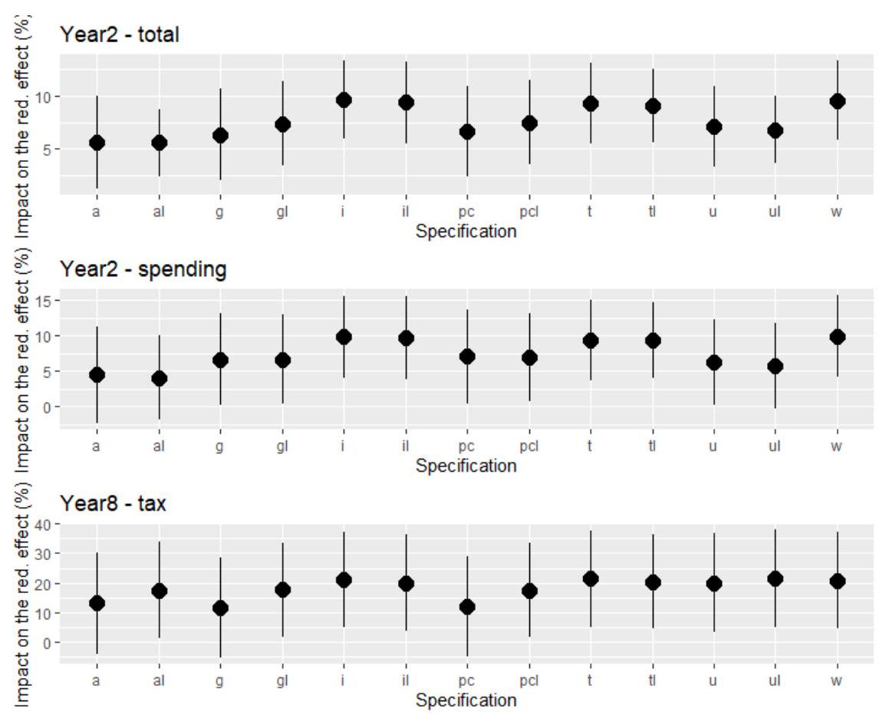
Source: Author's calculations. We present the coefficients with one standard deviation band around them. "a": all variables (all control variables are included), "g": real GDP growth rate, " i ": inflation rate, "pc": real GDP per capita, "t": trade-to-GDP (openness), "u": unemployment rate, "w": without control variables (baseline). "al", "gl", "il", "pcl", "tl" and "ul" control for the same variables, but adding one lag.

Fig.49B Impact of fiscal consolidation (of 1% of GDP) on the redistribution measure -Different countries
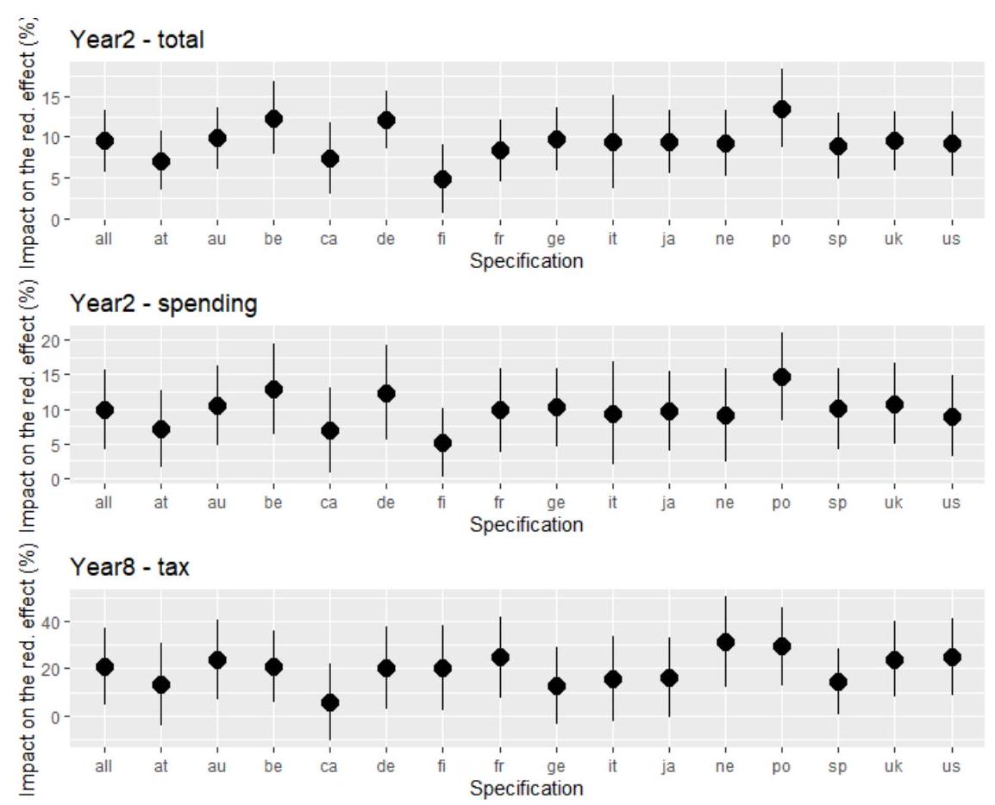
Source: Author's calculations. We present the coefficients with one standard deviation band around them. "all" includes all countries (baseline), "at" includes Austria, "au" excludes Australia, "be": excludes Belgica, "ca": excludes Canada, "de": excludes Denmark, "fi" excludes Finland, "fr" excludes France, "ge" excludes Germany, "ne" excludes Netherlands, "sp" includes Spain, "uk" excludes the United Kingdom, "us" excludes the United States.

Fig.50B Cumulative Response of the Redistribution Measure (change in %) to a fiscal consolidation of 1% of GDP- Three types of fiscal shock (total, spending-based and tax-based) - Robustness test - Estimations using Devries et al. 2011 (1978-2009) and Alesina et al. 2019 (2010-2014)
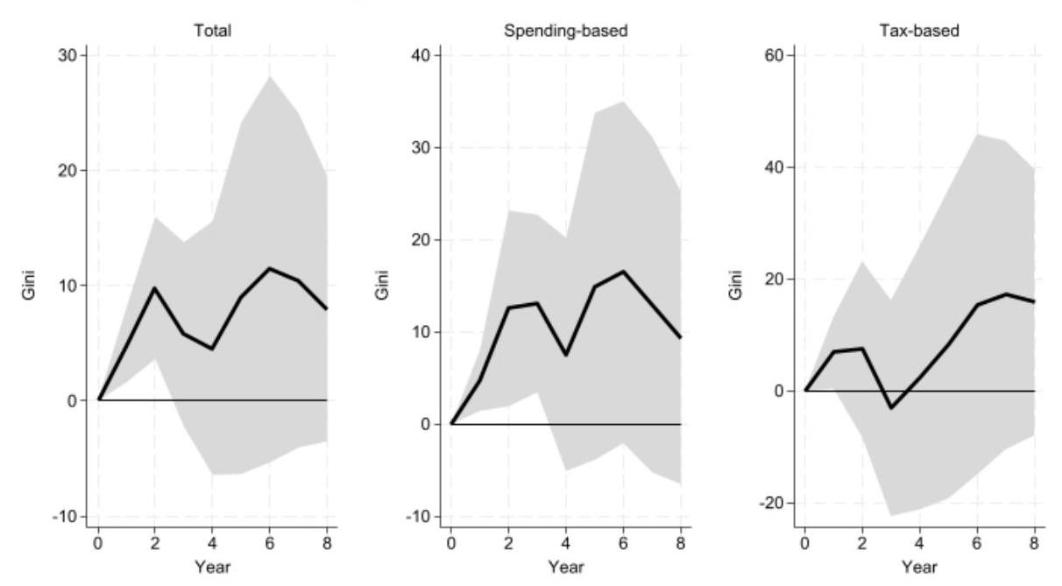
Source: Author's calculations.
Fig.51B Cumulative Response of the Redistribution Measure (change in %) to a fiscal consolidation of 1% of GDP- Three types of fiscal shock (total, spending-based and tax-based) - Robustness test – Estimations using Gupta et al. (2017): Devries et al., 2011 (1978-2009), Alesina et al., 2015 (2010-2013), Gupta et al., 2017 (2014)
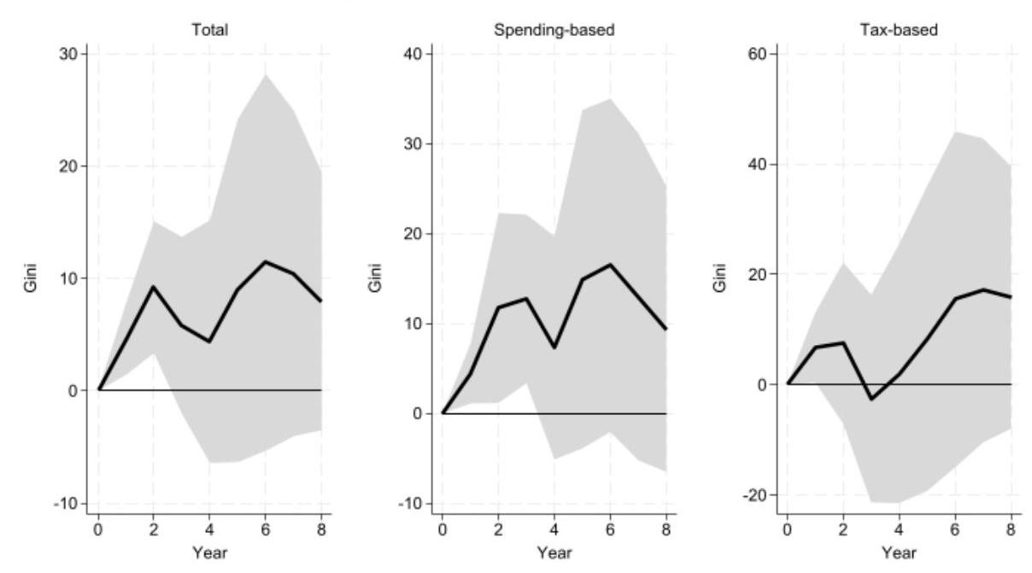
Source: Author's calculations.
Fig.52B Cumulative Response of Disposable Income Inequality (change in %) to a fiscal consolidation of 1% of GDP- Two types of fiscal shock (spending-based and tax-based)- Additional robustness test
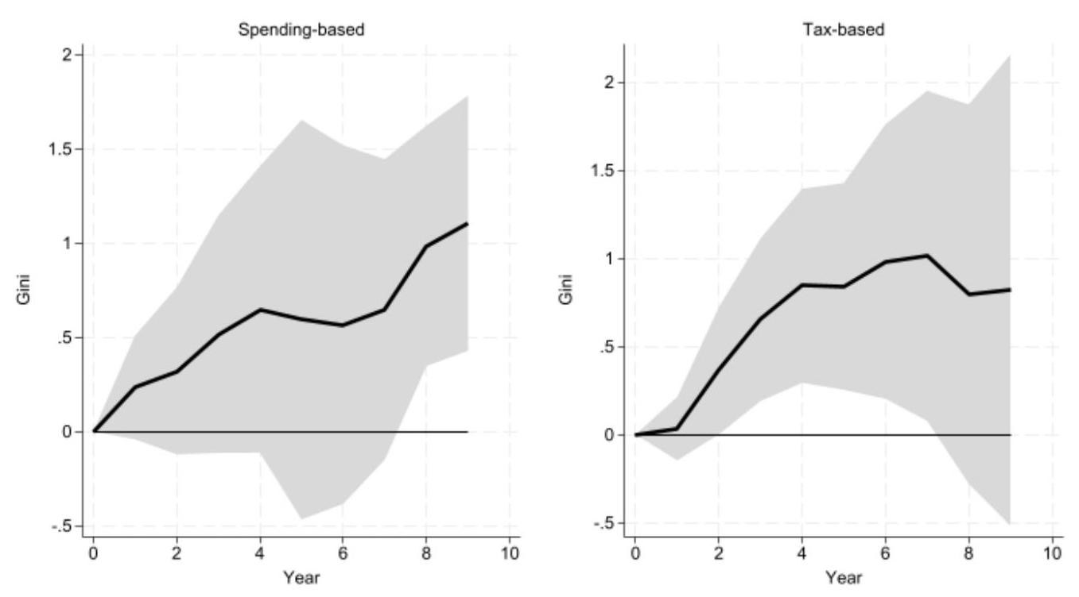
Source: Author's calculations.
Fig.53B Cumulative Response of Market Income Inequality (change in %) to a fiscal consolidation of 1% of GDP- Two types of fiscal shock (spending-based and tax-based)- Additional robustness test
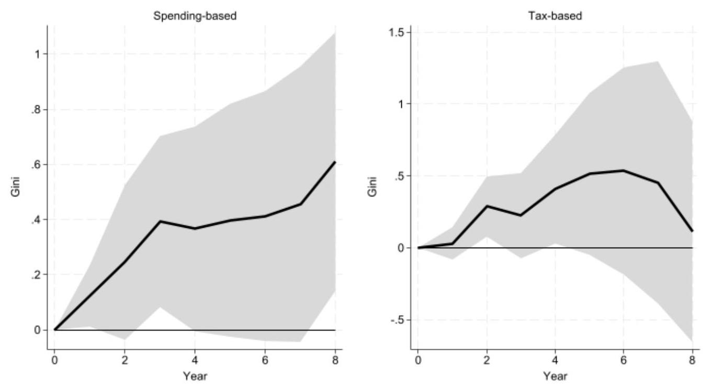
Source: Author's calculations.

Fig.54B Cumulative Response of Gross Wage Inequality (change in %) to a fiscal consolidation of $1\%$ of GDP- Two types of fiscal shock (spending-based and tax-based) - Additional robustness test
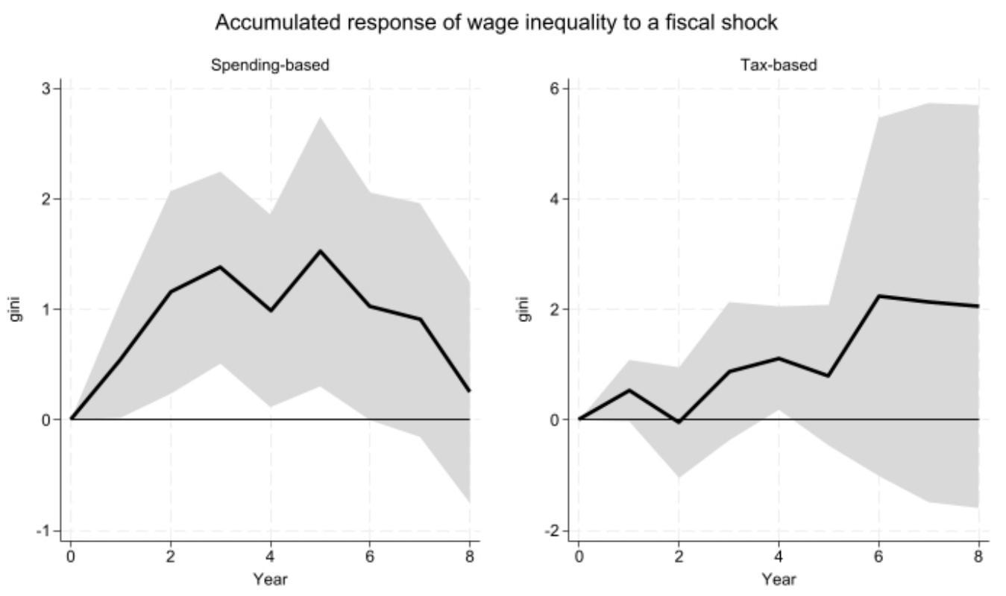
Source: Author's calculations.
Fig.55B Cumulative Response of the Percentile Ratio (50/10) (change in %) to a fiscal consolidation of 1% of GDP- Two types of fiscal shock (spending-based and tax-based) - Additional robustness test
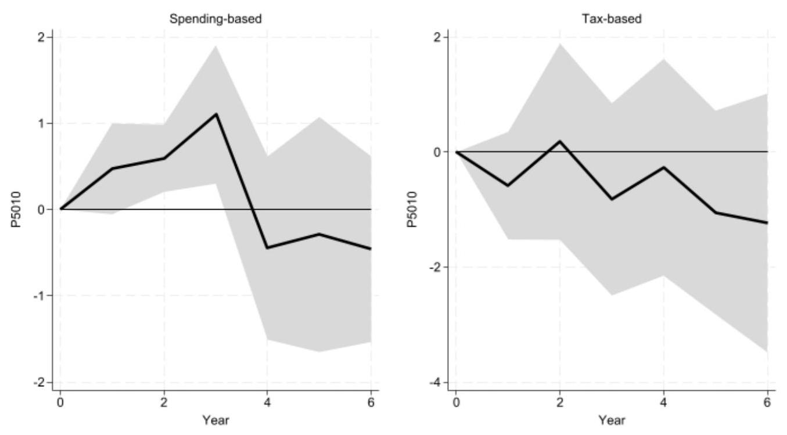
Source: Author's calculations.
Fig.56B Cumulative Response of the Percentile Ratio (90/50) (change in %) to a fiscal consolidation of 1% of GDP- Two types of fiscal shock (spending-based and tax-based)- Additional robustness test
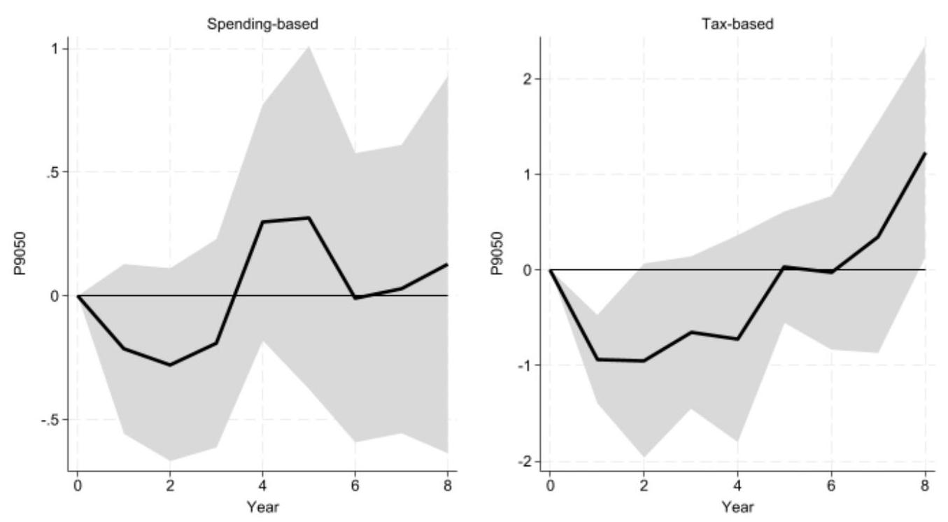
Source: Author's calculations.
Fig.57B Cumulative Response of the Percentile Ratio (90/10) (change in %) to a fiscal consolidation of 1% of GDP- Two types of fiscal shock (spending-based and tax-based)- Additional robustness test
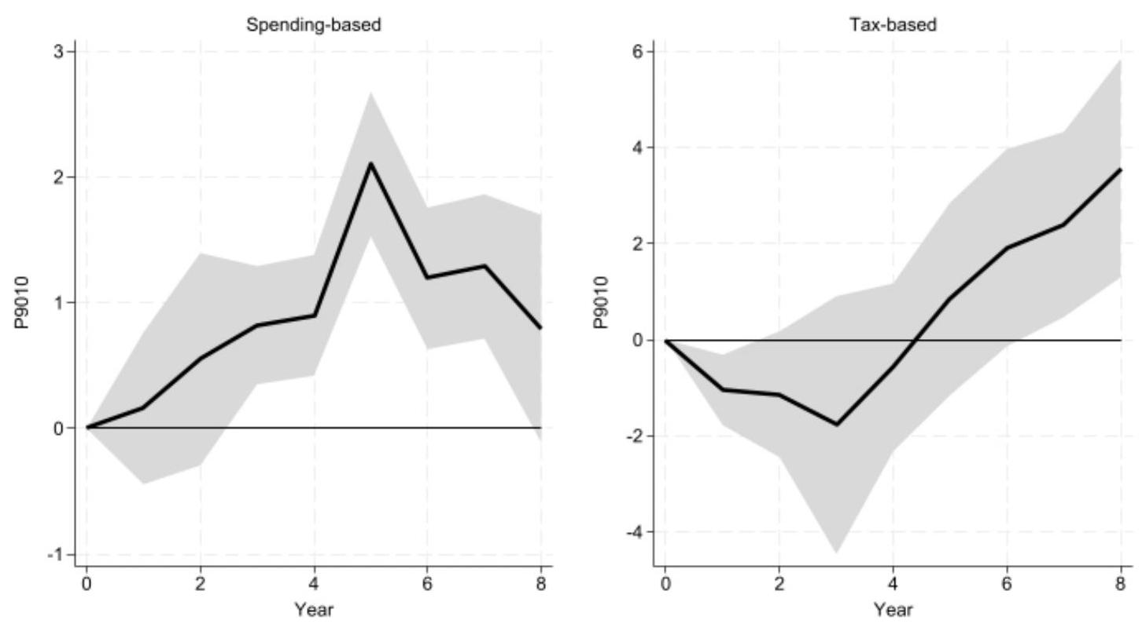
Source: Author's calculations.

Fig.58B Cumulative Response of the Labor Share in income (change in %) to a fiscal consolidation of 1% of GDP- Two types of fiscal shock (spending-based and tax-based)- Additional robustness test
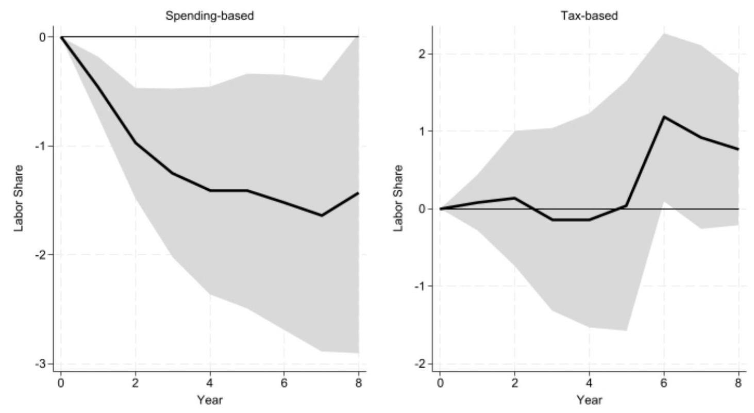
Source: Author's calculations.
Fig.59B Cumulative Response of the redistributive measure (change in %) to a fiscal consolidation of 1% of GDP- Two types of fiscal shock (spending-based and tax-based)- Additional robustness test
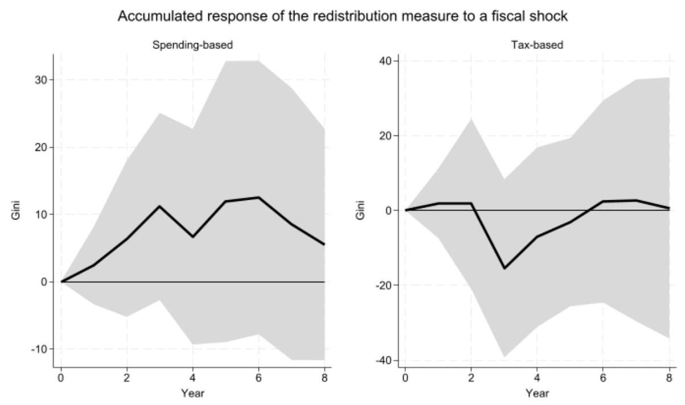
Source: Author's calculations.
Fig.60B Cumulative Response of Gross Wage Inequality (change in %) to a fiscal consolidation of 1% of GDP- Two types of fiscal shock (spending-based and tax-based) - Additional robustness test - one standard deviation band
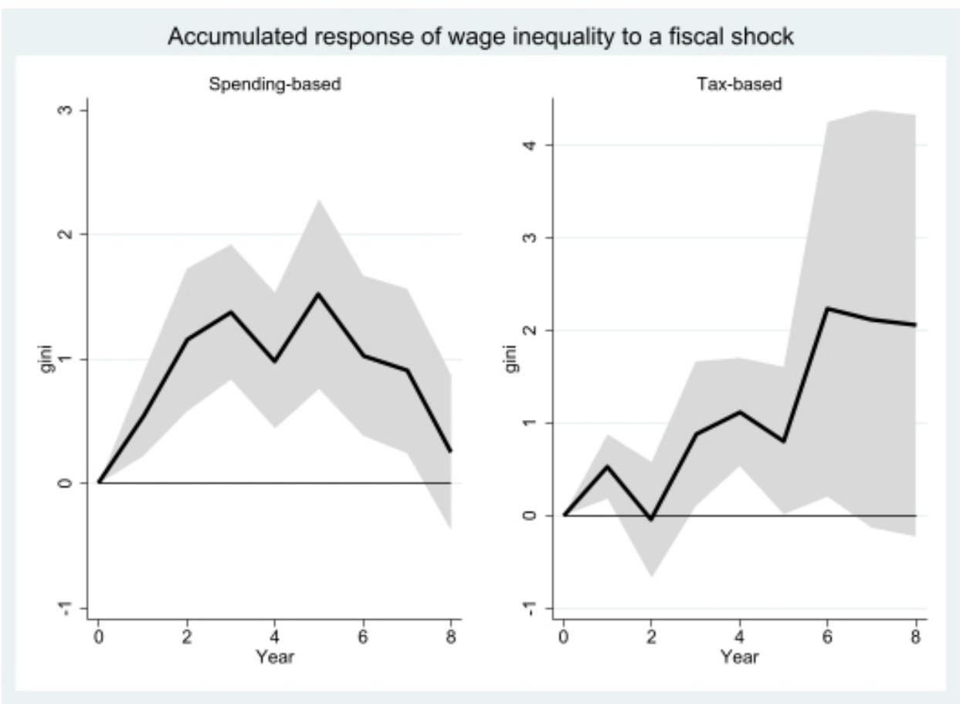
Source: Author's calculations.
Fig.61B Cumulative Response of the Redistributive Measure (change in %) to a fiscal consolidation of $1\%$ of GDP- Two types of fiscal shock (spending-based and tax-based) - Additional robustness test, with one standard deviation band
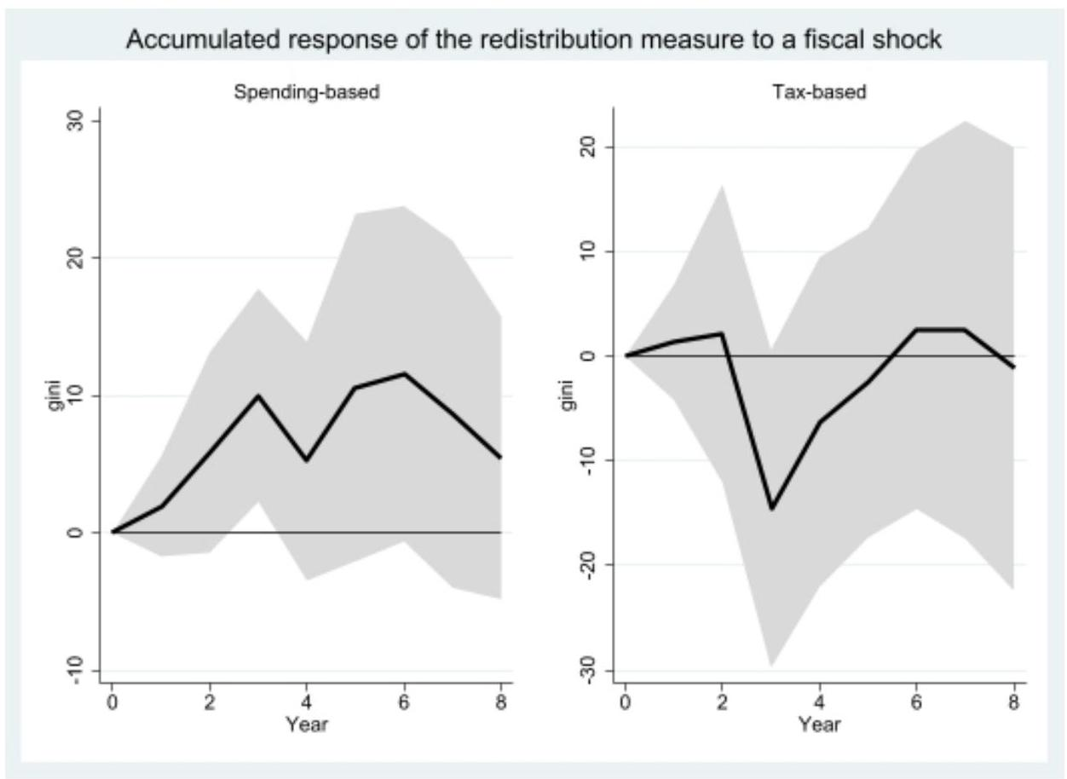
Source: Author's calculations.

In some specifications, the peak response changes. For example, for the 90/10 percentile ratio exercise, when including Portugal, the peak response considered is year seven for total and spending-based shocks (instead of five in the baseline). For the wage inequality exercise, when excluding Australia, Finland, Denmark and the Netherlands together, the peak response occurs in years three (short run) and six (medium run) for spending-based shocks.

